

SESSION 2022

BACCALAURÉAT PROFESSIONNEL

ÉPREUVE ORALE SPÉCIFIQUE « SECTION EUROPÉENNE »

SPÉCIALITÉ CONDUCTEUR TRANSPORT ROUTIER MARCHANDISE
CTRM

LANGUE : ANGLAIS

SUJET N°1

Durée de l’épreuve : 40 minutes

- Préparation | - 20 minutes
- Présentation de la situation | - 10 minutes
- Entretien sur les activités et travaux effectués dans la discipline non linguistique | - 10 minutes

SITUATION :


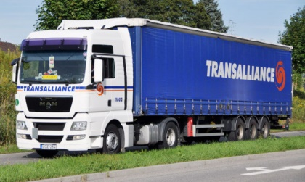
A businessman, Frank Robinson, is visiting the transport company in which you are employed, Transalliance UK, in Burton-on-Trent, to see the fleet of vehicles, before deciding to do business with your company or with another one.
The operations manager asks you to be in charge of the visit.

Use the clients’ testimonies and reactions to convince him to work with Transalliance UK.

DOCUMENTS :

- N° 1 : Information about your company
- N°2 : The fleet
- N°3 : Clients’ testimonies and reactions

DOCUMENT 1 : INFORMATION ABOUT YOUR COMPANY

Name : Transalliance UK
Location : Burton-on-Trent, UK
Type of transport : road and multimodal transport (train, boat, plane)
Type of goods : bulk, general goods, fresh and frozen food, liquids
Turnover (Transalliance Group) : 505 M€
Turnover (Transalliance Burton-on-Trent) : 15 M€
Client : 14 800 (UK, Europe, International)
Employees (Transalliance Group) : 2 750
Employees (Transalliance Burton-on-Trent) : 30
Number of companies in the corporate family : 132
Sustainable company : environmentally friendly waste management at the logistics sites + 3 year action plan to cut CO2 emissions.
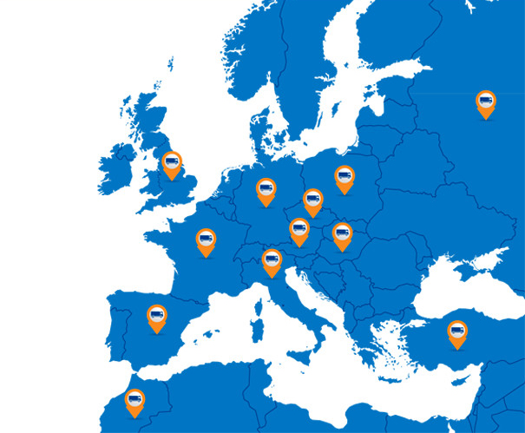

Source : https://www.transalliance.eu/en/transport

DOCUMENT 2 : THE FLEET
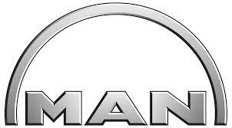

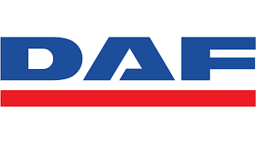


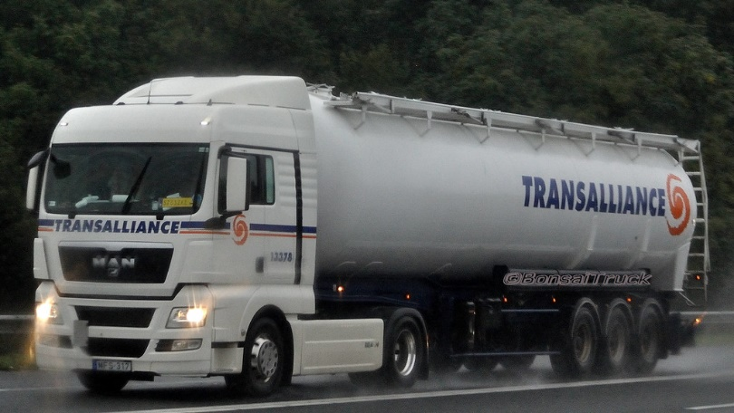
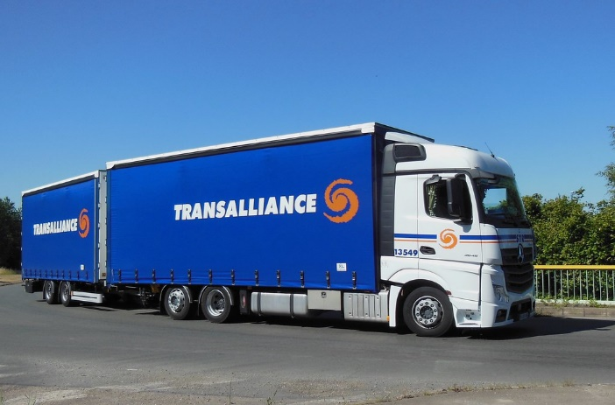

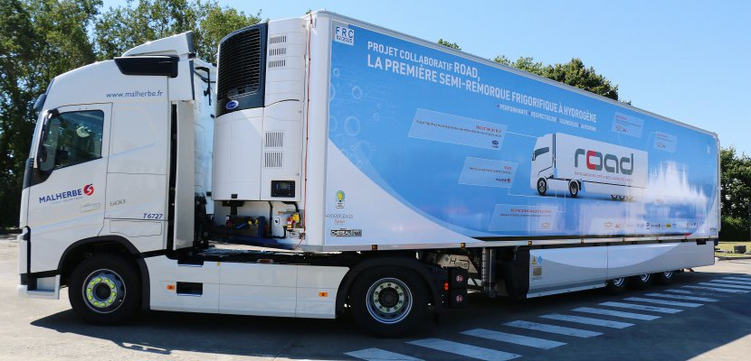
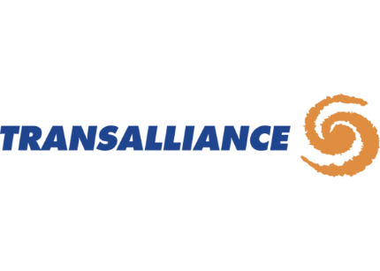
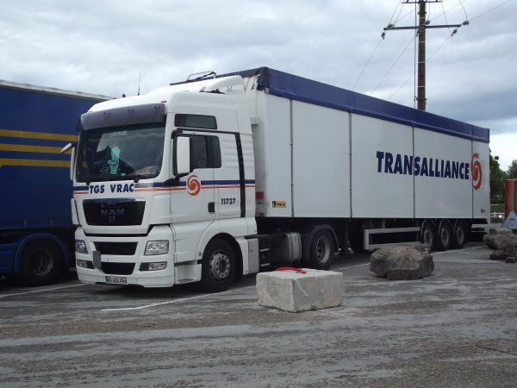

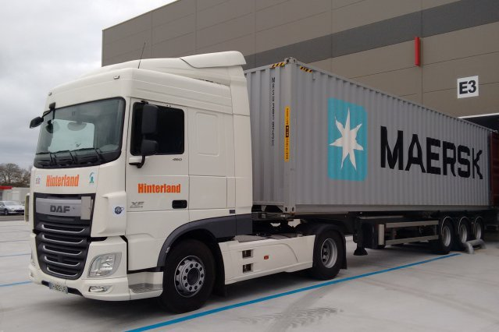



Source : Google Images

DOCUMENT 3 : CLIENTS’ TESTIMONIES AND REACTIONS

Professionalism, efficiency and high spirits
A dynamic and smiling team. Always prompt to listen, provide advice and do everything possible to accompany and satisfy customer demand.
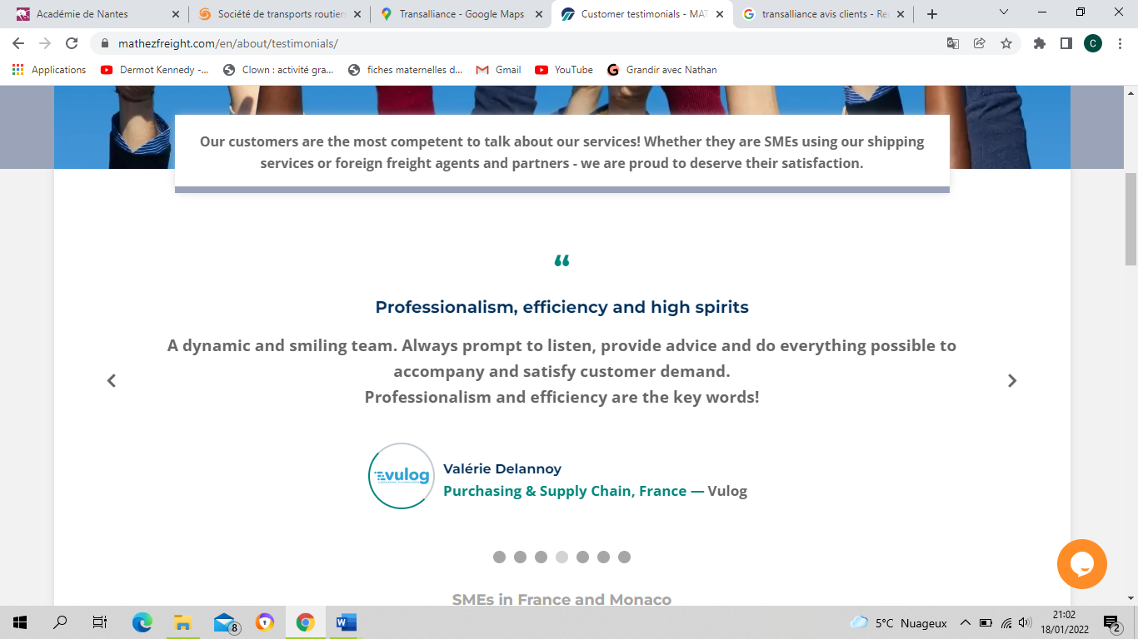

Expertise and responsiveness
It is always a pleasure to deal with teams that are very responsive. The expert advice of the team has helped us to develop our company in an optimal way.
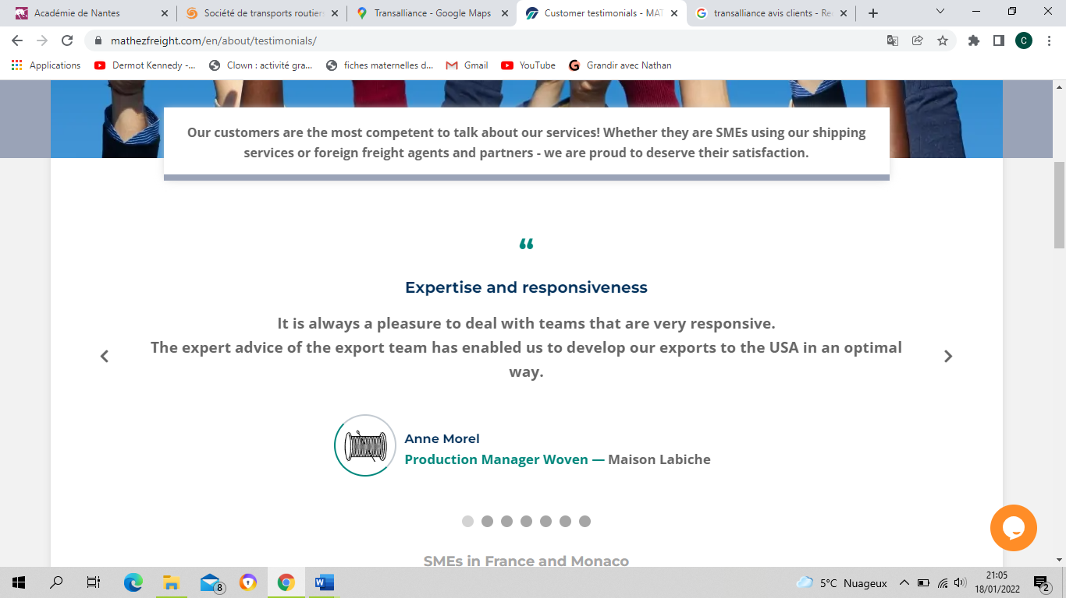

Solutions, rather than problems
We have chosen Transalliance as our preferred agent in the UK, and all the problems we have encountered in the past have disappeared. The team is super proactive : it presents us with logistical solutions, not problems. We are completely satisfied.
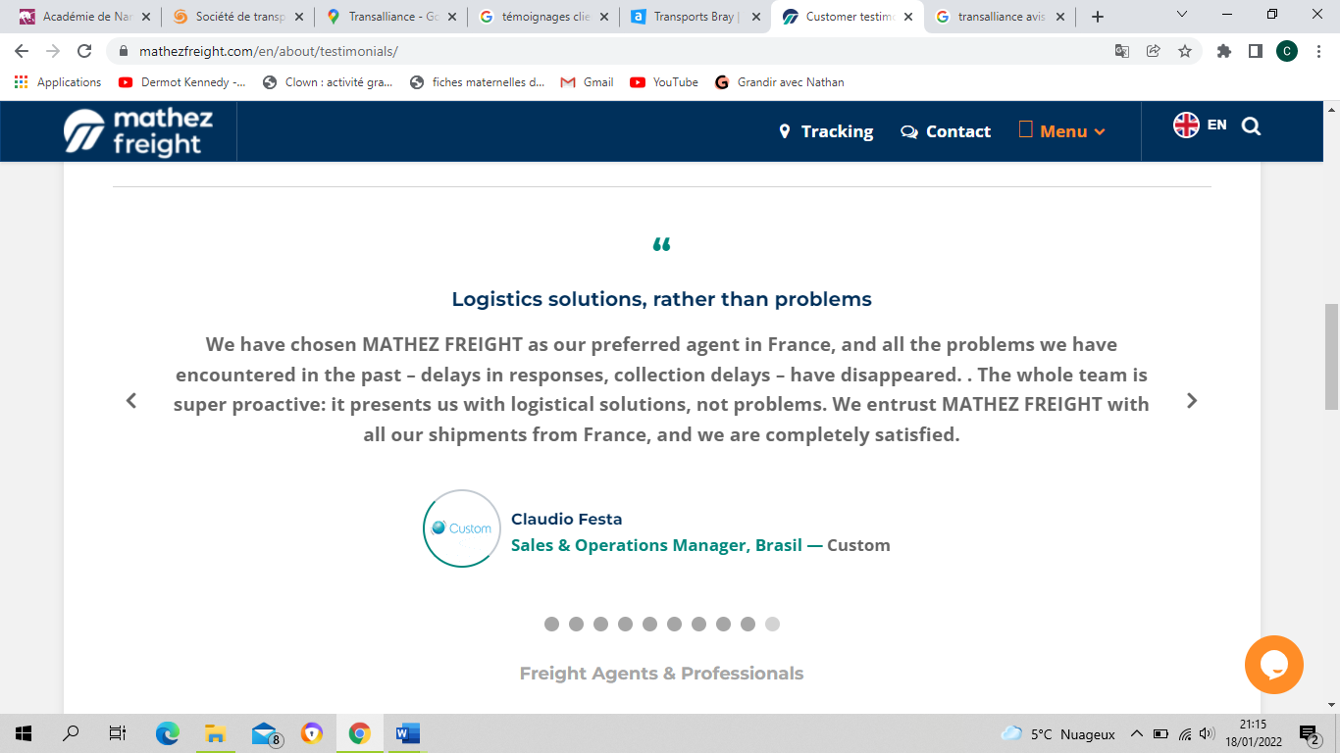

Very professional
I have known and worked with Transalliance for the last 10 years and I appreciate their professionalism. During the years I had the opportunity to test their ability to listen to their partners, solve problems, deal with international cultures and different mentalities.
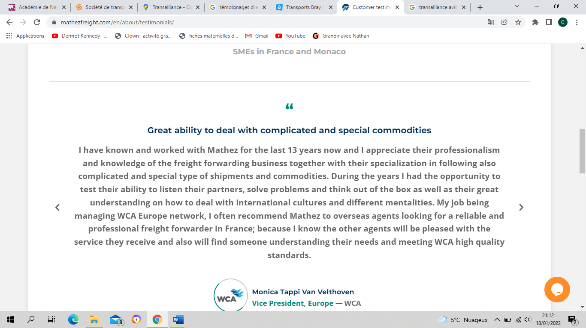

Source : https://www.mathezfreight.com/en/about/testimonials/

