CHRISTMAS EVE

Recopie et surligne les mots qui ressemblent au français :

Santa wakes up
………………………………
Santa puts on clothes
…………………………………..
Santa has breakfast
…………………………………..
Elves bring presents
……………………………………..
Elves and Santa have lunch
…………………………………………………......
Santa wakes Rudolf up
……………………………………………………….
Santa finally wakes Rudolf up
………………………………………………………
Santa, elves and Rudolf have a big dinner
……………………………………………………………………….
Santa puts on red suit
……………………………………………………………………….
Santa attaches Rudolf to sleigh
……………………………………………………………………..
Santa and Rudolf take off !!!
……………………………………………………………..
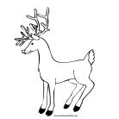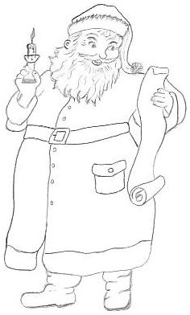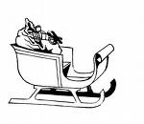

…………………. ……………………… ……………………… …………………….

Complète : | 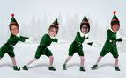  ………………………
Santa wakes …………..
Santa ……………… clothes
Santa ………… breakfast
Elves bring ……………..
Elves and Santa ……………. Lunch
Santa ………………. Rudolf up
Santa ……………….. wakes Rudolf up
Santa, elves and Rudolf have a ……….dinner
Santa puts on ………. suit
Santa attaches Rudolf …….. sleigh
Santa and Rudolf ……….. off !!!

