Bingo "Hello, goodbye"

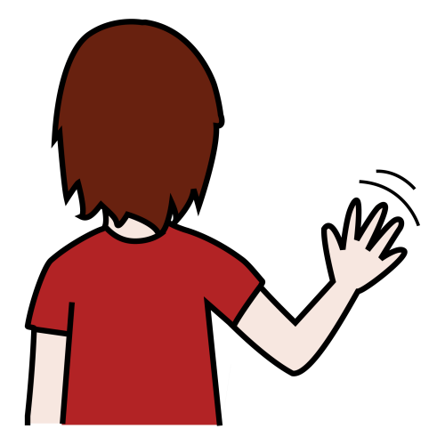 | 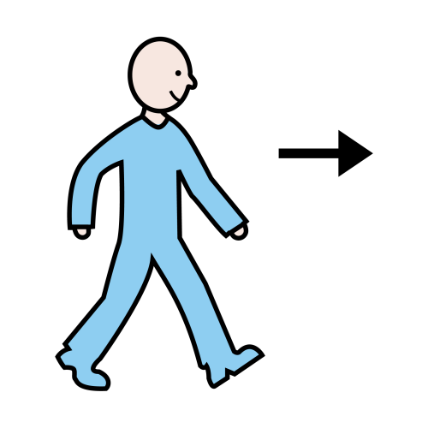
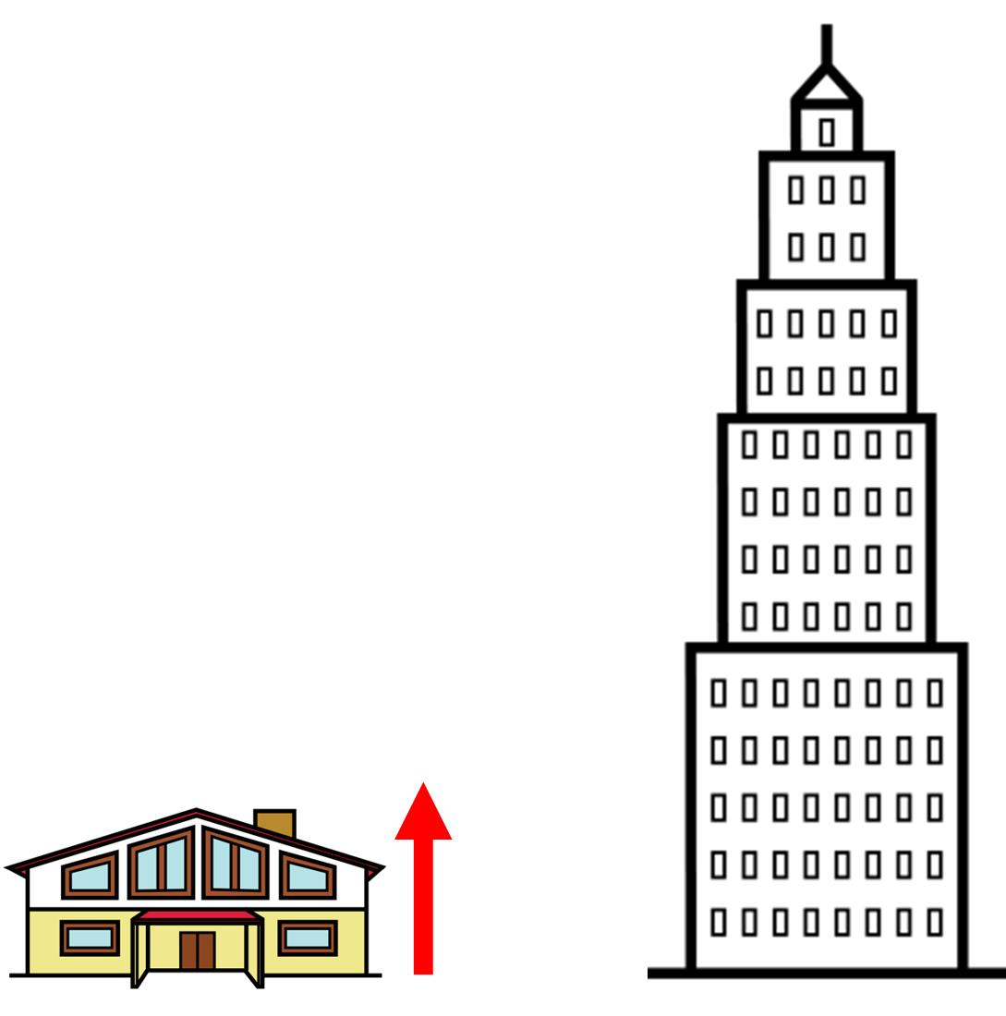 | 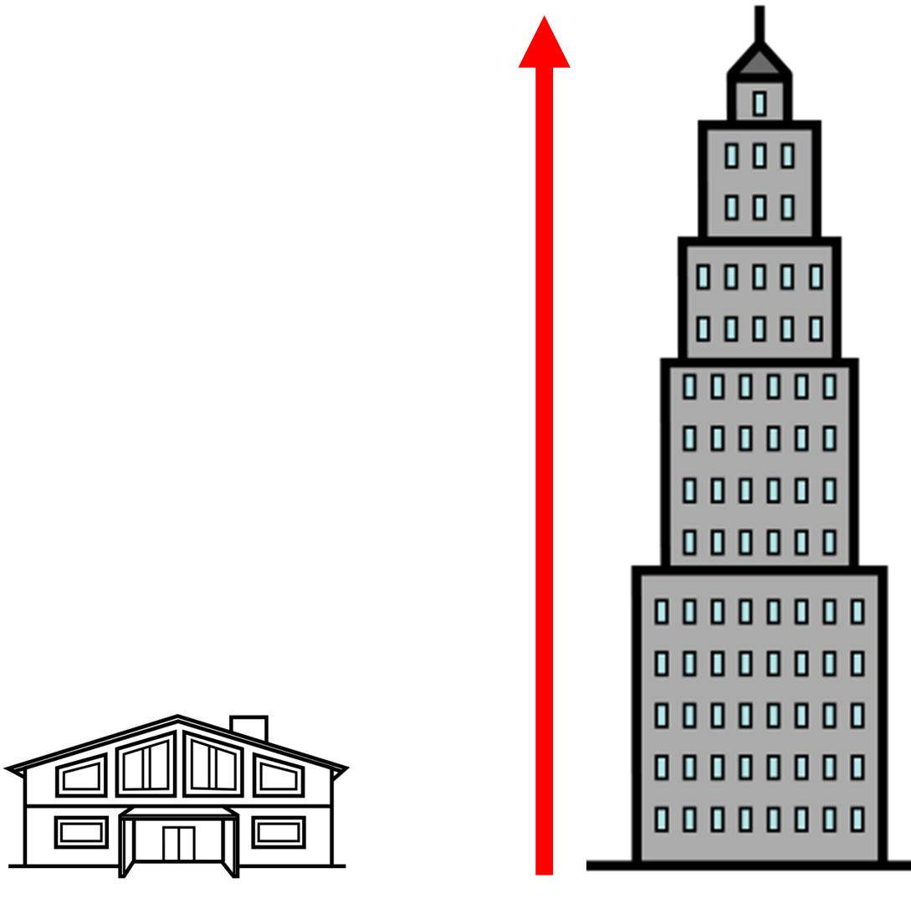
 | 

Bingo "Hello, goodbye" | Bingo "When I'm gone"

 | 
 | 
 | 

Bingo "Hello, goodbye" | Bingo "When I'm gone"

 | 

Bingo "Hello, goodbye" | Bingo "When I'm gone"

Bingo "Hello, goodbye" | Bingo "When I'm gone"

Bingo "Hello, goodbye" | Bingo "When I'm gone"

Bingo "Hello, goodbye" | Bingo "When I'm gone"

Bingo "Hello, goodbye" | Bingo "When I'm gone"

Bingo "Hello, goodbye" | Bingo "When I'm gone"

Bingo "Hello, goodbye" | Bingo "When I'm gone"

Bingo "Hello, goodbye" | Bingo "When I'm gone"

Bingo "Hello, goodbye" | Bingo "When I'm gone"

