

SESSION 2022

BACCALAURÉAT PROFESSIONNEL

ÉPREUVE ORALE SPÉCIFIQUE « SECTION EUROPÉENNE »

SPÉCIALITÉ TECHNICIEN MENUISIER

LANGUE : ANGLAIS

SUJET N°1

Durée de l’épreuve : 40 minutes

- Préparation | - 20 minutes
- Présentation de la situation | - 10 minutes
- Entretien sur les activités et travaux effectués dans la discipline non linguistique | - 10 minutes

SITUATION :


You are in charge of welcoming a new temporary woodworker from Staffing Match in your company, M. MCMANUS.

The person comes from the other side of the city, BURNOPFIELD. He will work on the assembly of timber to build a wooden structure to separate space in a house and create a dressing room.

Explain to him the safety rules in the wood workshop business, in particular how to use a nail gun and the work to be done step by step.

DOCUMENTS :

- N° 1 : SAFETY FIRST
- N° 2 : NAIL GUN SAFETY

DOCUMENT 1 : SAFETY FIRST

What safety procedures should you follow when using woodworking machines?

- Always wear safety glasses or goggles, or a face shield (with safety glasses or goggles).
- Wear hearing protection that is suitable for the level and frequency of the noise you are exposed to in the woodworking area.
- Use gloves to protect hands from splinters when handling wood but do not wear them near rotating blades and other machinery parts where the gloves can catch.
- Wear protective footwear.
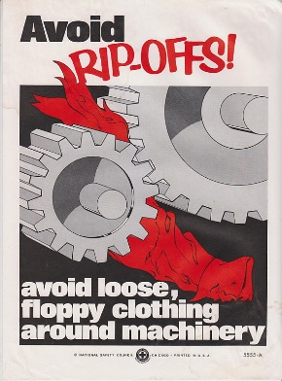
- Make sure the guard is in position, is in good working condition, and guards the machine adequately before operating any equipment or machine. Check and adjust all other safety devices.
- Make sure the equipment is properly grounded before use.
- Check that keys and adjusting wrenches are removed from the machine before turning on the power.
- Inspect stock for nails or other materials before cutting, planing, routing or carrying out similar activities.
- Make sure that all machines have start and stop buttons.
- Turn the power off and unplug the power cord (or lock out the power source) before inspecting, changing, cleaning, adjusting or repairing a blade or a machine. Also turn the power off when discussing the work.

http://ccohs.ca/oshanswers/safety_haz/woodwork/gen_safe.html

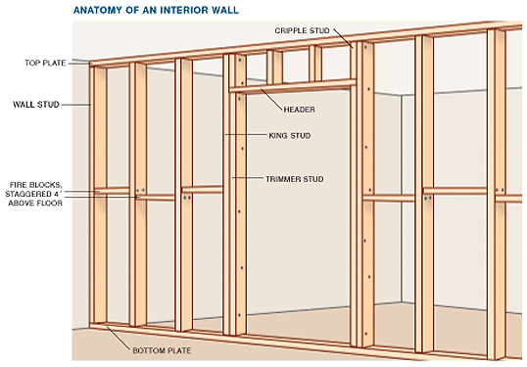
DOCUMENT 2 : NAIL GUN SAFETY
https://www.worksafebc.com/en/resources/health-safety/posters/nail-gun-safety-11-x-17?lang=en
Picture from : https://www.hometips.com/how-it-works/interior-wood-wall-paneling.html

