Doing Physics with Superman

Document 1 : What explanations did the authors of Superman give to his strength ?
In the late 1940s, the texts described the people of Krypton as ordinary humans and looked for the origin of Superman's powers in physics.

The source of the powers of the Man of Steel lies in the difference in gravity between Krypton, his planet of birth, and the Earth.
Action Comics #1 (June 1938), the debut of Superman. Cover art by Joe Shuster. © DC Comics DC Comics – Siegel - ShusterComics

Document 2 : Extract from a comic
DC Comics – Siegel - ShusterComics

Document 3 : Some informations on Earth and Krypton
http://web.stanford.edu/~jbboin/doc/superman.pdf

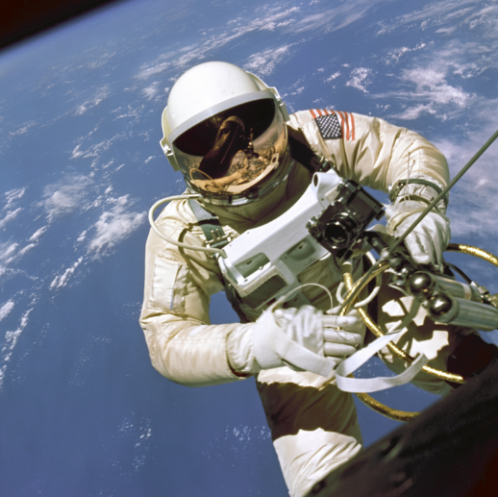
Document 4 : Newton, his apple and one spationaut
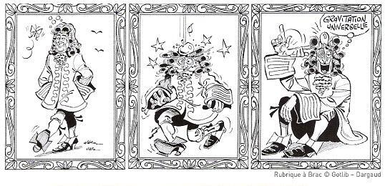 | Edward White during EVA. During the Gemini 4 mission, White became the first American astronaut to perform a spacewalk

Using the different documents and Audacity, write and record the speech of Superman’s father.

Your speech must explain the word « gravity » and describe the factors influencing the gravity of a planet.

