England is finding new ways to crack down on unhealthy foods
by Hanna Ziady , CNN Business,December 28, 2020
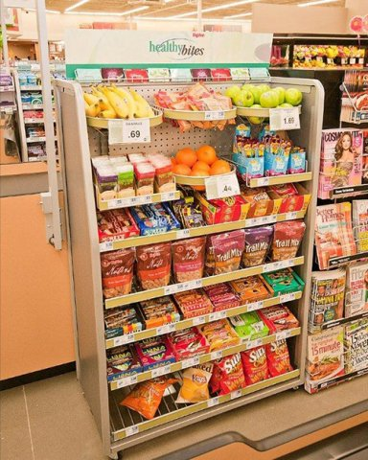
Temptation at checkout
The food and drink industry has warned of "devastating" results for consumers and businesses if the UK government moves ahead with plans to restrict how supermarkets sell and advertise chocolate, soda and other foods high in sugar, salt and fat as part of a wider push to tackle obesity.
The new rules will apply to retailers in England with more than 50 employees and are due to kick in by April 2022, the Department of Health and Social Care said. Small stores and specialist retailers, such as chocolatiers and sweet shops, will be exempt from some of the restrictions.
Offers for unhealthy foods that require shoppers to buy more items to take advantage of the discount — such as "buy one get one free" or "3 for 2" promotions — will be prohibited in stores and online. The constraints extend beyond chocolates, soft drinks, sweets and potato chips to pastries, breakfast cereals, pizzas, ready meals and battered products, such as breaded chicken.
Unhealthy promotions will no longer be allowed in "key locations," such as checkout counters, store entrances and at the end of aisles. Free refills of sugary soft drinks in restaurants will also be banned.
The new measures will ensure that "the healthy choice is the easy choice," Public Health Minister Jo Churchill said in the statement. "Creating an environment which helps everyone eat healthier foods is crucial to improving the health of the nation," she added.
But the Food and Drink Federation, which represents manufacturers, said the policy will have "harsh economic impacts" for producers and consumers.
"The proposed restrictions will not only increase the cost of food for families but it will have harsh economic impacts for food and drink manufacturers who are already bracing themselves for the costs of Brexit and the repercussions of the COVID-19 pandemic," Chief Operating Officer Tim Rycroft said.
Britain introduced restrictions on television advertising to children of unhealthy foods in 2007 and implemented a tax on sugary soft drinks in 2018. Earlier this year it launched a new campaign to address obesity, which includes proposals to require restaurants to add calorie labels to menu items.
Almost two thirds of adults in England are overweight and one in three children leave primary school overweight or obese, according to the government.
To implement: mettre en place

