UNIT 1 Producing and sharing knowledge – Education in South Africa
Central question : what are the challenges of education in South Africa? And how has it evolved since the Apartheid regime ?

- Record a podcast on the South African education system -

The situation : you are a journalist working for Radio Africa. You seize the opportunity of the anniversary of the Amnesty report to discuss the state of education in South Africa with 2 guests, a pupil and a teacher. (5 minutes)

Success criteria :
- As the journalist :
- I prepare a creative and solid introduction in which I welcome the listeners, I refer to the report & explain the topic of the podcast, and finally introduce the guests (and who they are !).
- I prepare about 10 varied questions to cover the topic.
- I am ready to react to my guests’ answers before asking the next question.
(cf video on the anniversary of Bantu education : the journalist expresses her shock)
- I also prepare an imaginative conclusion in which I thank the guests, conclude and refer to the next programme aired.

- As guests :
- I choose my role and I prepare my answers to the questions, finding help in the documents studied.
- I can make my answers more personal by illustrating them with statistics or imagined personal anecdotes.

- My vocabulary is adapted to the situation. (ex : curriculum, and not national programme !)
- I practise beforehand in order to avoid reading.
PREMIERE AMC - DEVOIR DE SYNTHESE - THEME : KNOWLEDGE, CREATION, INNOVATION
Durée : 2 heures – dictionnaire unilingue autorisé
Write a short commentary (minimum 300 words) on documents A, B and C in which you will explain how education is portrayed in modern-day South Africa.
Document A (source : Moran Blueshtein, University of Pennsylvania, 2013)
Racial Disparities in Schooling: Evidence From Cape-Town, South Africa

Abstract

Racial disparities in education in South Africa have been large and enduring post-apartheid.
In this dissertation, I study several potential explanations for the racial disparities and also evaluate policies aimed to mitigate them. The estimation is based on 1420 males age 12-22, drawn from Cape Area Panel Study (CAPS).
I find that apartheid heritage explains 40% of the African-white gap in years of schooling, and 16% of the colored-white gap in years of schooling. My findings highlight the role of financial constraints in explaining racial disparities in education. I find that abolishing secondary school fees in all secondary schools will eliminate 49% of the schooling gap between African and whites and 42% of the schooling gap between coloreds and whites.
The findings suggest that financial constraints are more important at the secondary school level than they are at the college level. Abolishing college fees without altering secondary school fees will mostly benefit whites and will have a small effect on African and colored schooling.

Document B (source : Al Jazeera, January 10, 2019 )
Outrage over apparent ‘segregation’ in South Africa school
An image of a classroom with black and white children separated sparks controversy in post-apartheid South Africa.
A South African primary school teacher was suspended on Thursday after a photograph appeared to show black children sitting separately from white children in a classroom, sparking a storm of racism accusations.
The pupils were attending their first day at the Schweizer-Reneke school in North West province, and the teacher had taken a photograph to send to anxious parents.
It rapidly spread on social media as it showed about 17 white children sitting around a large table, with four black children around a small corner table in the background.
“From the information I got from the meeting, it seems that there are a lot of cases here of racism,” provincial Education Minister Sello Lehari said after visiting the school.
“I will send a team to do an investigation into all schools… to deal with issues of racism in totality,” Lehari said.
Student activist Mcebo Dlamini wrote on social media that “ black kids ostracized from white kids, is common in our supposedly post-apartheid Africa”, South African news website TimesLIVE reported.
Race relations remain tense in South Africa 25 years after the end of white-minority apartheid rule, with fierce racism-related controversies erupting regularly on social media and in politics.
Document C : Average total household consumption expenditure attributed to education by population group of household head (source : Living conditions survey, 2014/2015)

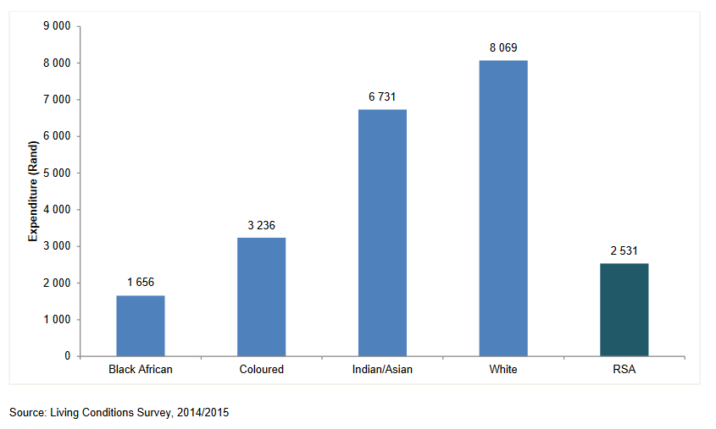

Devoir de transposition
Rendez compte en français des principales idées exprimées par ce document de manière organisée. Critères d’évaluation :
Niveau | Score
C1 – pour info : peut rendre compte de l’essentiel des idées, de manière claire et bien structurée
B2 – peut rendre compte de l’essentiel du contenu de manière cohérente | 20
B1 – peut rendre compte des points principaux, même si la présentation comporte des maladresses | 14
A2 – peut prélever des informations et en rendre compte | 9
A1 – peut rendre compte de quelques informations | 4
Helpful vocabulary :
- An uprising = a revolt
- A thread : un fil
- To bind = to connect
- To future-proof one’s livelihood : sécuriser son avenir
- At a snail’s pace = very slowly
- A boundary = a limit
- The altar : l’autel
NB : Pour reconnaitre la structure du texte = suivre les mots de liaison !
« On the one hand … on the other hand… » => expriment les différences
Both generations => annonce un point commun
« in conclusion » => annonce que ce qui suit résume ce qui est dit précédemment, de manière plus synthétique, et peut vous aider à comprendre le propos du texte.

As South Africa marks the 42nd anniversary of the 1976 Soweto student uprisings the spotlight returns on the condition of today’s youth and their counterparts of the time.
Among the more pronounced threads that bind these generations of young people can be found in the sphere of education. On the one hand, the 1976 Soweto student uprisings tragically ended with hundreds of young people killed by the apartheid government when they protested the imposition of Afrikaans as a medium of instruction. On the other hand, today’s youth is equally vibrant and exhibits fearless activism for universal access to quality education and transformation of the national curriculum to future-proof their livelihoods.
The 2015 #Feesmustfall marches led by vibrant youth across the country and disruptions in tertiary institutions perceived to take a snail’s pace approach to transformation shows the parallels between the youth of the two generations.
Both generations demonstrated a burning desire to push the boundaries, ask the uncomfortable questions and not sacrifice at the altar of preserving peace, the need for real, meaningful transformation.
In conclusion, while the youth of 1976 fought with their lives for freedom and the creation of a democratic state, today’s youth activism should be strengthened as it tackles poverty, inequality and unemployment. It is heartening to note that the clear majority of South Africa’s youth are not passive but are champions of their own development as active members of society.
Musa Ndlangamandla, tyi.co.za, June 15th 2018.

