THEME 1 : Knowledge, Creation, Innovation
1 . 1 : Producing and sharing knowledge
Topic : An unequal access to knowledge in post-apartheid South Africa
Central question : How has education in SA evolved since the end of Apartheid ?
Final project : record a podcast on education
Context : This year marks the first anniversary of the publication of Amnesty’s report on education in South Africa.
As a journalist working for Radio Africa, you record a podcast on which you and your guest discuss the state of education in the country. Be able to refer to the various issues studied in class !

Objectives
Culture | Gram | Vocab | phonology
South Africa fast facts  The South African school system  Apartheid / Bantu Educat° Act  University education  Possible reading =Trevor noah : Born a crime | The passive voice  asking questions | Education  Apartheid / Inequalities  Bridging the gap | Accentuation emphatique  The various sounds of the letter <a>
communicationnels | - analyse statistique  - s’exprimer devant le groupe à partir de notes (« free speech corner » activity de début d’heure)  - organiser son propos pour le podcast (introduction, conclusion, transitions) et réagir à un propos émis

Introduction | Objectif de séance : présentation du thème / du pays / du système éducatif  - quotes on education : which one(s) do you (dis) agree with and why ? discuss with your group  - then focus on South Africa : a few facts about the country = Kahoot quiz  - Trace écrite sous forme de texte à trous reposant sur les réponses au quiz + google maps : alexandra vs sandton.  https://www.google.fr/maps/place/Marion+St,+Sandown,+Sandton,+2196,+Afrique+du+Sud/@-26.1003951,28.0635917,6094m/data=!3m1!1e3!4m5!3m4!1s0x1e9573242f3cd6b9:0xd8ff40654e453409!8m2!3d-26.094696!4d28.060416  - Présentation séquence (thème / problématique / projet final)  - activité de phonologie sur le grapheme <a> / grammaire : rappel usage article « the »  - Presentation of the South African high school system and class / group discussion around the various subjects they can choose to study. (Primary & secondary education chart + explanation on how Grade 12 is organised + matric NSC exam)
Objectif de séance : comprendre le système de l’Apartheid
Listening task : what was Apartheid ? BBC News Apartheid 46 years in 90 seconds
Timeline & passive voice
Speaking practice : you are a guide at the Apartheid Museum in Jo’burg. Present the Apartheid regime to a group of tourists, from 5 photographs (video screenshots)

Part 1 : Educat° during the Apartheid regime | Objectif de séance : étudier le système éducation mis en place durant l’Apartheid et s’entrainer à s’exprimer à partir de notes  - Set of documents around the 1953 Bantu Education Act : act / article / video interview  - Récap en classe / méthodologie de la synthèse (via mindmap)  - Speaking practice : podcast practice : with the help of your mindmap, report on Apartheid-era education in 1 minute !
Part 2 : Today’s challenges | Objectif de séance : découvrir les nouveaux défis de l’Afrique du Sud concernant l’accès à l’éducation, s’entrainer à l’analyse statistique  - Brainstorming : what challenges can you imagine ?  - Photo à commenter => élèves (cartables, uniformes) marchant le long d’une route, situation d’insécurité (pas de trottoir, grande route, pas d’éclairage), semblent marcher depuis longtemps / aller loin (pas de bourg, maisons au loin, grande route) = aller à l’école semble risqué / dangereux  - Graph analysis activity in groups = explain to the goup what challenge to education it represents  - writing practice : creative writing : react to these challenges / personal diary…
Challenge focus : a limited access due to one’s social background
student worksheet : Video & Literary extract
entrainement méthodo synthèse : how do these documents portray education in South Africa ?
entrainement transposition à partir de l’extrait littéraire
The report :
- anticipate from title / source and comment on the choice of words
- matching activity : themes / paragraphs
- in pairs : start working on your recording.
Part 3 : various solutions  (exposés) | - edtech / digitization  - e-learning  - mobile schools
 | PODCAST FINAL PROJECT
 | Synthèse on bantu education & transposition

UNIT 1 : THE UNEQUAL ACCESS TO EDUCATION IN SOUTH AFRICA
THEME 1 : Knowledge, Creation and Innovation
Axis 1.1 : Producing and Sharing Knowledge
Central question : How has education evolved in South Africa since Apartheid ?
Final project : Speaking task : Record a podcast on education
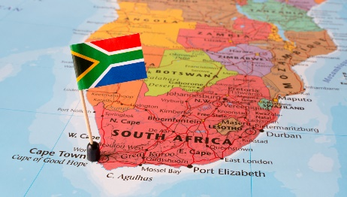
INTRODUCTION - South Africa – a few facts !
South Africa is located in the ……………………………….. hemisphere and its
Southern tip is called the ………………………………..…………………………
It counts ……….. provinces :
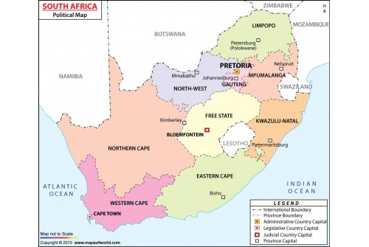
This country actually has ……….. capital cities corresponding to the 3 branches of power, namely :
- ………………………………… , for the ………………………………. power,
- …………..…………………….. , for the ………………………………. power,
- and ………………………………… , for the ………………………………. Power
Even more surprisingly, it counts ………….. official languages, which include : …………………………………,
………………………………… and ………………………………… It is therefore very important to understand that for many South Africans, English is not their mother tongue !
Its official currency is the ……………………. (1€ is worth about 18R)
A dark and impactful historical period for the country was the ………………………………… regime, which lasted between 1948 and ………. and which implemented segregation on grounds of race. (= based on).
Today, South Africa thrives and attracts a lot of tourists, who wish to admire its jaw-dropping landscapes, such as …………………………………, ………………………………… or ………………………………, and get to spot its diverse wildlife : …………………………………, ………………………………… or ………………………………… ! If you are brave enough to drive up the ……………………………… mountains, then you can even step into the Kingdom of ……………………………… , which is landlocked in South Africa !
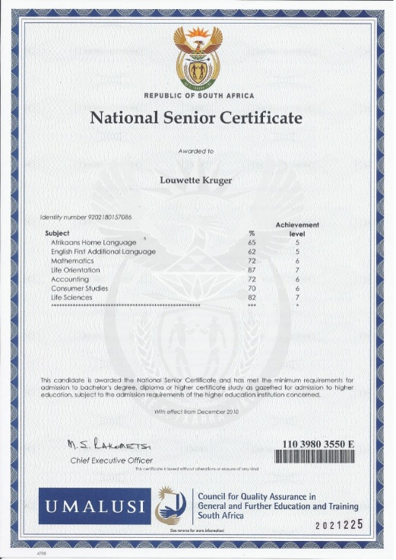
However, behind the varnish of the Rainbow flag lies a darker reality : South Africa is still divided along colour lines, notably in its cities, where white-populated posh suburbs are door to door to black-populated derelict ………………………………

A few facts about South African education system :
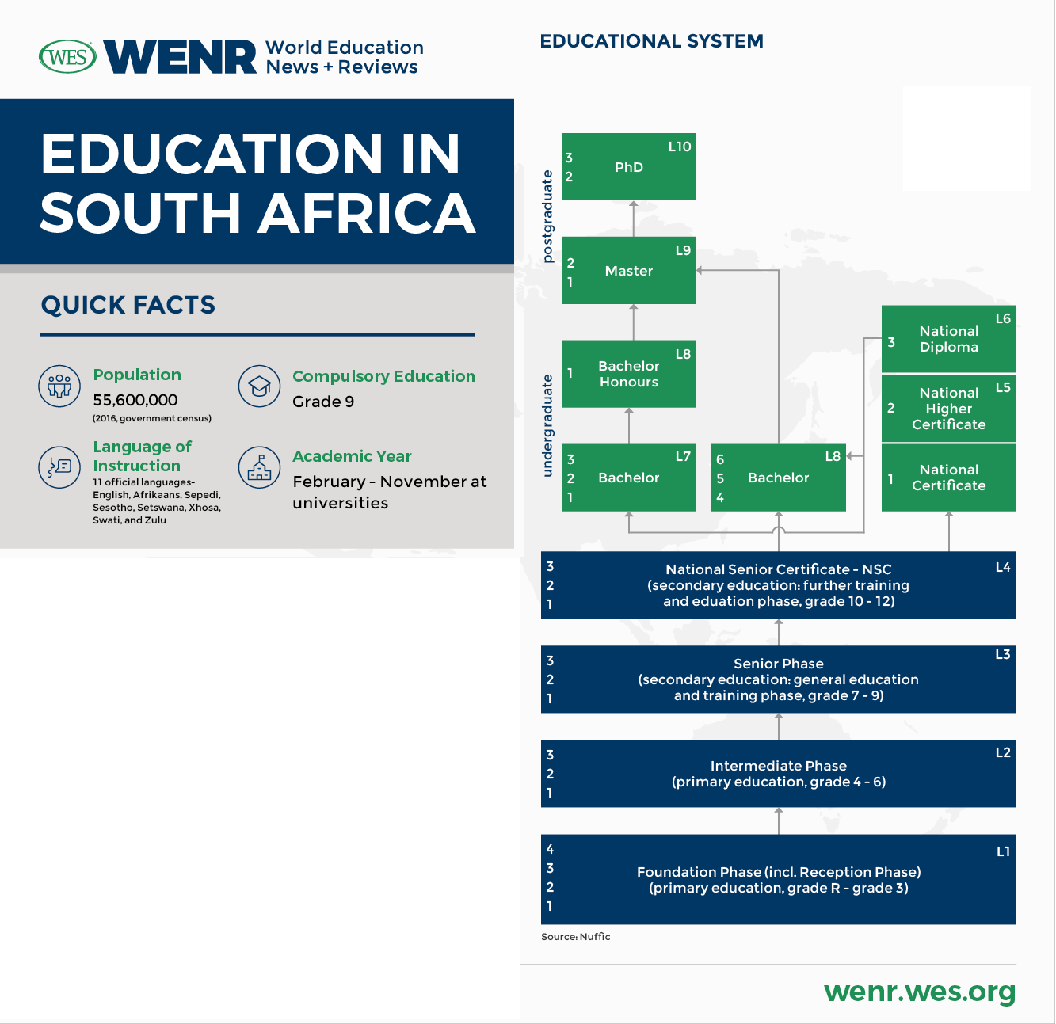

More words about the school system :
- School breaks up ! c’est les vacances !
= The pupils break up : les élèves sont en vacances.
- School resumes : l’école reprend
= children go back to school
- Une classe : a form (UK), a year (Aus), a grade (US)
- a period : une heure de cours
- a course : un cursus (ex : to take a course in chemistry : suivre un cursus de chimie)
- to sit / take an exam : passer un examen
- to pass an exam : réussir un examen // to fail : échouer
- a MOCK exam : un examen blanc
- To repeat a year : redoubler

- Phonology corner: the various pronunciations of the letter <a> in English

Listen to these words and classify the sound made by the letter <a> accordingly in the corresponding column:

education, Africa, face, Apartheid, what, challenges, Apartheid, are, tackle; Africa, share, fall

/ / as in "cat" | / / as in "car" | /ei/ as in "cake" | /e / as in fair | / / as in "pot" | / / as in "door" | / / as in "better" | /i/ as in “private”

And then, what about these ones ?

water, facilities, syllabus, academic, academic, graduate, graduate, attend, disadvantaged,

disadvantaged, afford, amount, appropriate, appropriate

- Pronouncing the article « the »
Listen carefully and guess the rule : the article but the word

Practise !
- The Apartheid regime - the information shared in the report
- The speech delivered today - the audience gathered here
- The African continent

- And, when do we need to use the article « the » ?
Observe & guess the rule : President Ramaphosa but the president

L’Afrique du Sud : ………………………………. les Sud-africains : ……………………………….
L’Apartheid : ………………………………. le regime de l’Apartheid : ……………………………….
PART 1 - Education during Apartheid.
Document 1
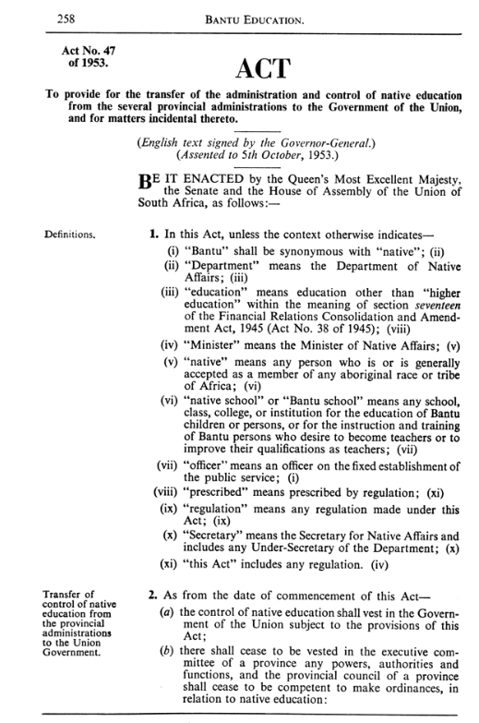
- What type of document is it ?
It is a piece of legislation, entitled « Bantu Education Act »

- When was it published ?
It was published in 1953 = during Apartheid = during a period when the Government implemented racial segregation and separated public facilities, like schools.

- Who does it focus on ? (read the definitions carefully !)
It targets the Black population, referred to as « Bantu » here.

- What was it about ?
To understand that, you need to read carefully the objective of this Act, which is detailed in the bottom left-hand corner :
« transfer of control of native education from the provincial administrations to the Union Government ». = we understand that the central Government took control of the education of Black people.

- We can wonder : why ? and what were the consequences of that move ?

Let’s read Document 2 to find an answer to these questions :
Explanatory notes extracted from sahistory.org.za website.
In 1953, prior to the apartheid government’s Bantu Education Act, 90% of black South African schools were state-aided mission schools. The Act demanded that all such schools register with the state, and removed control of African education from the churches and provincial authorities. This control was centralized in the Bantu Education Department, which was dedicated to keeping it separate and inferior.
The financing of education for Africans was also separated from general state spending and linked to direct tax paid by Africans themselves, with the result that far less was spent on black children than on white children.
Nationally, pupil:teacher ratios went up from 46:1 in 1955 to 58:1 in 1967. Overcrowded classrooms were used on a rota basis. There was also a lack of teachers, and many of those who did teach were underqualified. In 1961, only 10 per cent of black teachers held a matriculation certificate [last year of high school]. Black education was essentially retrogressing, with teachers being less qualified than their students.

- What were the consequences of that decision on the education of Black South-Africans ? (focus on the schooling conditions and the quality of teaching)
- Lines 6-7 : it was less financed, received less money = we can imagine that the buildings were not well maintained, the equipment was poorer for instance.
- Line 8 : the classrooms were overcrowded as the number of pupils per teacher skyrocketed.
- Line 9 : not enough teachers were recruited = teachers were lacking. And the teachers hired did not have the necessary skills to teach at the required level.

- Ultimately, what was the objective of the Government with such a move ? (think of the Apartheid regime)
- Lines 4 & 11 : their objective was to segregate education = keep Black Africans in a separated structure, and provide them an education that will maintain them in this position of inferiority. So, in terms of education, the goal was not to teach them too much (hence the word « retrogressing ».
A double strategy was adopted :
- Impoverishing the schooling conditions (overcrowded classrooms and less financing)
- Worsening the quality of teaching
In doing so, the Government could delegate them to low-profile jobs and assert the superiority of the white community.
Indeed, the less they’d know, the less likely they were to question their situation and stand up for their rights.
Controling education is a means to control a population.
The less you educate people, the less likely they are to question the decisions taken.
In Apartheid South Africa, education and knowledge were not accessible to Black communities to keep them powerless.

LANGUAGE STOP : using the « neither… nor … structure (« ni…ni… » en français)
Observe this sentence : Neither the school facilities, nor the teaching were satisfactory / adequat.
- - +

- the negation is included in the “neither / nor structure” and therefore not repeated on the verb.

Translate !

a) beaucoup d'élèves ne parlaient ni anglais ni Afrikaans.
Many students spoke neither English nor Afrikaans.

b) le Gouvernement n'a offert ni locaux adaptés ni professeurs formés. (former = to train)
The Gvt offered neither adapted facilities nor trained teachers

c) ni l'ONU ni la Couronne n'ont poussé l'Afrique du Sud à démanteler l'Apartheid.(démanteler = take down)
Neither the UNO nor the Crown pushed SA to take down Apartheid.

Document 3
https://www.youtube.com/watch?v=kn1ITFpAVDI
- Identify the context the journalist is presenting
- identify the effects of Bantu education on the South-African school system.
- Understand the interviewee’s conclusion on today’s schooling conditions in the country.

The journalist is announcing the 60th anniversary of the Bantu Education Act, which was passed in 1953. We understand that this extract is already 8 years old.

According to her guest, this Bantu Education Act has marked the South African education system really deeply and two current aspects are its legacies :
- First, corporal punishments unfortunately persist in some schools, although it was officially outlawed in 1996.
- Besides, Black schools were still underfunded compared with white institutions for nearly two decades !

As of today, progress has been made, with the passing of legislation such as the South African Schools Act, which aims to promote fairness and equality in education and to develop a democratic school system.

