PART 2 : CHALLENGES TO EDUCATION FOR ALL IN SOUTH AFRICA
Analysing statistics and reporting orally :
- Match each statistical figure to its corresponding title
Figure 1 | Education attainment among individuals aged 25-64 by population group, 2016
Figure 2 | Household expenditure on education by population group, 2016
Figure 3 | Current attendance at post-secondary institution for individuals aged 17-40 by population group, 2016
Figure 4 | Expected years of schooling or primary, secondary and post-secondary levels by population group, 2016
Figure 5 | Mode of transport used by students to get to educational institutions, 2016
Figure 6 | Time taken in minutes walking to educational institutions by type of geographical areas, 2016

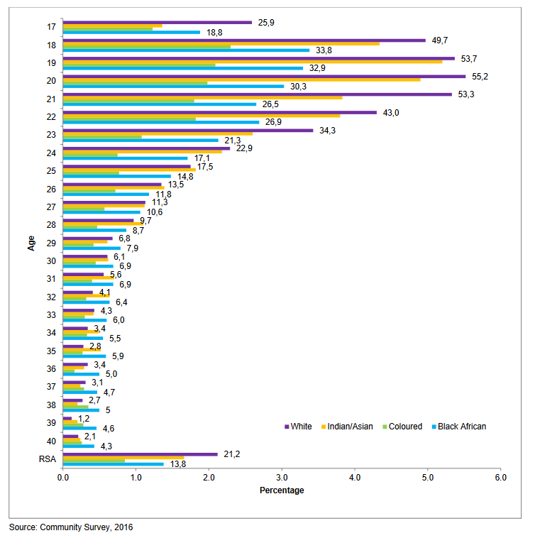
- Analyse the statistical figure given to you:
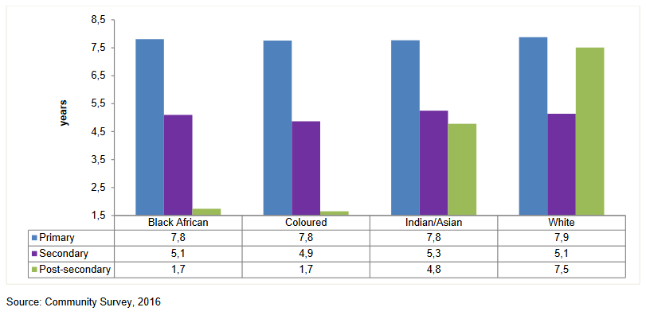

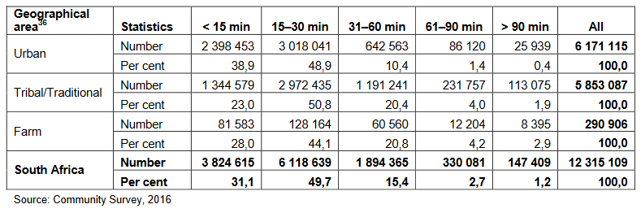

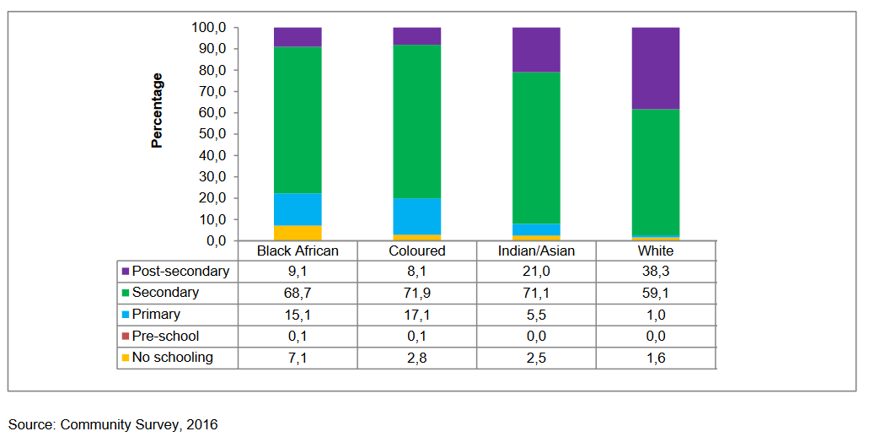
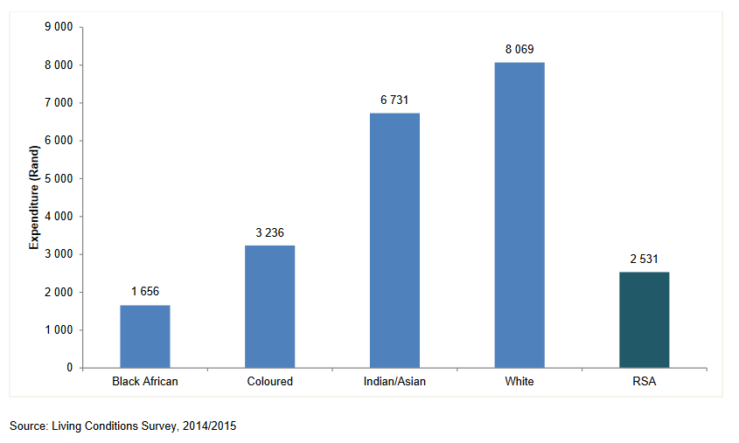
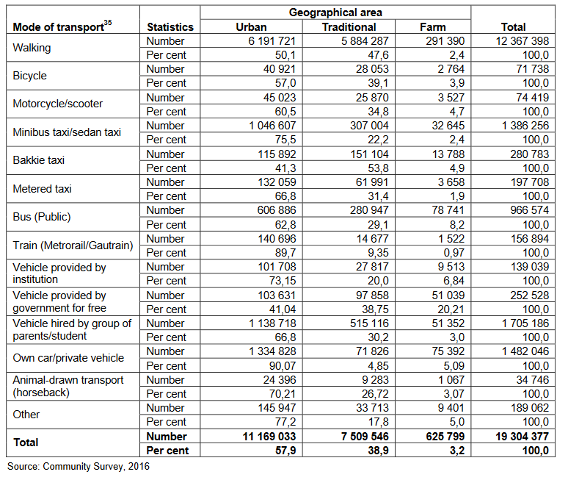

CHALLENGE FOCUS : Unequal access to knowledge based on social grounds

Document 1 : a video extract of « South Africa: Free education suffers from Apartheid legacy » (Learning World: S5E01, 1/3) (source : Wise Channel, 2014)

https://www.youtube.com/watch?v=rbYu9x0mOks watch until 2’39 !!
- Document 2 : a literary extract of Memoirs of a Born Free : Reflexions on the Rainbow Nation, written by Malaika Wa Azania in 2004.
Document 1 :
Journalist | Situation presented :  South Africa’s classrooms are ballooning thanks in a large part to a Government policy ……………………………………………….….. in some of the country’s poorest areas.  But newly-enrolled students face a besieged and bloated system with subpar ………………. often hindering ……………….. (supar=below standard)  - « ballooning » : explain in your own words  - Highlight the cause of that  - « besieged and bloated » : do you think it is negative or positive ?  - « hindering » : try to guess the meaning of this verb
1st interviewee | What does he say about the Government’s action ? (a monetary allocat° = a sum of money given)
Journalist | Take note of the various problems listed
2nd interviewee :  A …………. | Take note of the problem faced by teachers and her feeling
Journalist | Take note of two more problems noted by the journalist  Then, what is said about the place seen in the report ?
3rd interviewee :  A …………. | Where is he from and how did he feel upon arriving there ? Why ?
Journalist | His conclusion on the state of education in South Africa :
Document 2 :
Since my early childhood days as a young girl growing up on the dusty streets of Deadowlands, I have wanted to write a letter to the African National Congress (ANC) to express my gratitude for the role it played in the liberation struggle. But there were other issues that I wanted to address, issues that have nothing to do with gratitude. I wanted to tell the ANC what life in the township is really like. I have been aching to describe to the ANC, for example, how it felt to make a transition from township schools into former Model-C schools*, heavens of classism and racism.
Those of us who have had the unfortunate « privilege » of attending multiracial former Model-C schools have experienced firsthand what institutionalised racism means, because we are daily living in the boiling fire of white supremacy. Racism is institutionalised when a black child must wake up at an ungodly hour to take public transport to get to a « good » Model-C school while a white child need only walk there or get dropped off by their chauffeur in a German-made car.
Institutionalised racism is when schools in the townships have no science laboratories or computer classes while students in former Model-C schools have limitless access to media centres and libraries stocked with excellent resources. Institutionalised racism is when these students, those who have access to these resources, are accepted into universities where black students have the doors of learning shut in their faces. Institutionalised racism is when institutions of higher learning that are historically black, such as Walter Sisulu University, are being allowed to fall apart while ivory towers of white privilege, such as Rhodes University, continue to exist in vulgar wealth, operating similar to private schools. Institutionalised racism is a legalised form of apartheid that the so-called born-free generation is subjected to.
Malaika Wa Azania, Memoirs of a Born Free : Reflexions on the Rainbow Nation, 2004
Read the text and answer the questions :
- Make a sentence to introduce the text under study. (nature, author, year of publication & theme)
………………………………………………………………………………………………………………….
……………………………………………………………………………………………………………………….…………………………………………………………………………………………………………….
- Sum up the information we get about the narrator.
………………………………………………………………………………………………………………….
…………………………………………………………………………………………………………………………….……………………………………………………………………………………………………….
- In the text, focus on the places mentioned. Fill in the grid with the corresponding elements & their key characteristics :
 | Underpriviledged schools,  Often in Black areas | Priviledged areas,  mostly the white areas
Primary and secondary education
Higher education

- Sum up the author’s viewpoint on today’s education in South Africa.
………………………………………………………………………………………………………………….
…………………………………………………………………………………………………………………
SYNTHESIS WRITING PRACTICE : How do these documents portray education in modern day South Africa?

Methodology : Understanding and analysing a scientific report.
- Page 2 : Identify the source. Comment on their description.
…………………………………………………………………………………………………………………………………………………………………………………………………………………………………………………………………………………………………………………………………………………………………………
- Page 1 : Identify the theme of this report. Comment on the title.
…………………………………………………………………………………………………………………………………………………………………………………………………………………………………………………………………………………………………………………………………………………………………………
- Pages 4-5 : the contents.
- From the titles of the sections, highlight various challenges that are discussed in this report.
- Page 13 : Notice the presence of a list of ……………………………………………. which are here to help the readers, who may not be familiar with these acronyms.
- Page 14 : …………………………………………. : All scientific reports present statistics and therefore include a methodology section, which explains the readers how they operated to obtain these statistics. (when / for how long / who was targeted / what questions were asked…) & hence (d’où) the presence of annexes at its very end.
SKIM through the text and MATCH the paragraphs with the corresponding theme.
Lack of safety
Teaching-related problems
Responsibility of the Government / blame put on the Government
Legacy of Apartheid
Unequality in the country

Lack of transport
Inadequate facilities

Recommendations / solutions
Attack on health & dignity

Exemples of experiences across the country
Results of the survey
Unequal education system
Acknowledgments (=saying thak you)

- Then, highlight the problems raised.

- What difference(s) do you see between a report and a plea / a speech ? (in terms of language, tone, aim..)
……………………………………………………………………………………………………………………………………………………………………………………………………………………………………………………………………………………….……………………………………………………………………………………………………………………………………………………………………………………………..……………………………………………………………………….

