LGBTQI+ INCLUSION
AXIS 3: ART AND POWER AXIS 6: DIVERSITY AND INCLUSION
Question: To what extent is art effective in changing mentalities and promoting LGBTQI+ inclusion?
PART 1: MUSIC / A FOCUS ON GAY ANTHEMS

KEY QUESTIONS
What is a “gay music anthem”? What are the themes underlying gay anthems?
How have singers taken up the cause of LGBTQI to influence the society around them and decision-making? Can the releasing of a gay-friendly song be considered as “pink washing”?

Concepts, documents and sources

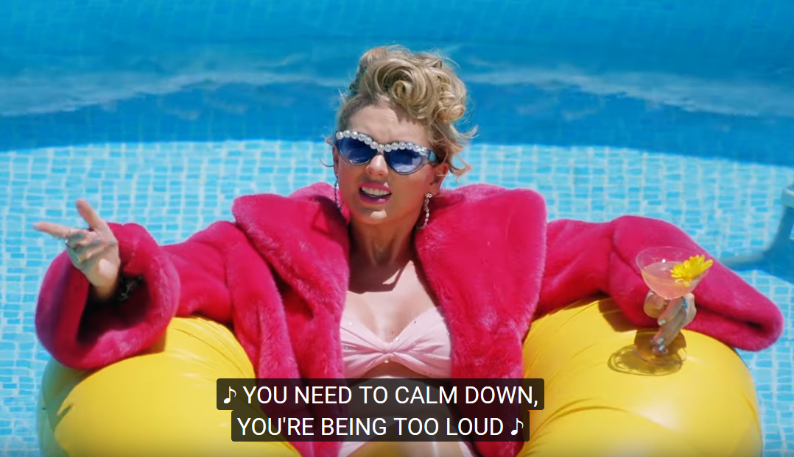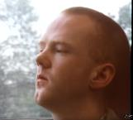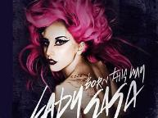
Same-sex marriage

Gay anthem Pink washing

Doc 1: A few definitions (incomplete list)

Gender identity
_____________________: A person who lives as a member of a gender other than that expected based on sex or gender assigned at birth. Sexual orientation varies and is not dependent on gender identity.
_____________________: a transgender person who was assigned male at birth but whose gender identity is that of a woman and who affirms their transgender history.
_____________________: a transgender person who was assigned female at birth but whose gender identity is that of a man and who affirms their transgender history.
_____________________: someone who feels comfortable with the gender identity assigned to them based on their sex assigned at birth.

Sexual identity

_____________________: Women who experience sexual, romantic, physical, and/or spiritual attraction to other women.
_____________________: Used in some cultural settings to represent men who are attracted to men in a romantic, erotic and/or emotional sense.
_____________________: A person who experiences sexual, romantic, physical, and/or spiritual attraction to more than one gender, not necessarily at the same time, in the same way, or to the same degree.
___________________________________: a person sexually attracted to people of the opposite sex.
_____________________: A person who does not experience sexual attraction. They may or may not experience emotional, physical, or romantic attraction. Asexuality differs from celibacy in that it is a sexual orientation, not a choice. People who are asexual may call themselves ace.
_____________________: A person who experiences little or no romantic attraction to others.
_____________________: An attraction to people regardless of their gender.
Gender expression
___________________________________: refers to people who do not follow other society's ideals or stereotypes about how they should look or act based on the sex assigned at birth.
___________________________________: refers to people who do follow society's ideals or about how they should look or act based on the sex assigned at birth.
Other terms
_____________________: A political statement, as well as a sexual orientation, which advocates breaking binary thinking and seeing both sexual orientation and gender identity as potentially fluid. The term is a simple label to explain a complex set of sexual behaviors and desires. For example, a person who is attracted to multiple genders may identify as _________. Many older LGBT people feel the word has been hatefully used against them for too long and are reluctant to embrace it. “________” can be used as an umbrella term to refer to all LGBTQI people.
_____________________: An individual who is unsure of and/or exploring their gender identity and/or sexual orientation.
_____________________: a set of medical conditions that feature congenital anomaly of the reproductive and sexual system. That is, these people are born with “sex chromosomes,” external genitalia, or internal reproductive systems that are not considered “standard” for either male or female. Their existence shows that there are not just two sexes and that our ways of thinking about sex (trying to force everyone to fit into either the male box or the female box) is socially constructed.
_____________________: Prejudice against individuals and groups who display non-heterosexual behaviors or identities, combined with the majority power to impose such prejudice. Usually used to the advantage of the group in power. Any attitude, action, or practice backed by an institutional power that subordinates people because of their sexual orientation
_____________________: Someone who confronts heterosexism, anti- LGBTQIA biases, heterosexual and cisgender privilege in themselves and others; believes that heterosexism, homophobia, biphobia, and transphobia are social justice issues.
Activity 1: match the concepts below to the definitions above.
AROMANTIC - ASEXUAL – BISEXUAL or BI – CISGENDER - GAY – HETEROSEXISM - INTERSEX - LESBIAN – LGBTQI ALLY - PANSEXUAL – QUEER – QUESTIONING - TRANS MAN – TRANS WOMAN – TRANSGENDER – HETEROSEXUAL/STRAIGHT - GENDER NON-CONFORMING - GENDER CONFORMING
Activity 2: practice pronouncing the 15 keywords using WordReference or Howjsay.

GAY ANTHEMS - Document 2 : “You Need to Calm Down”, Taylor Swift, 2019
Who does Swift address, directly and indirectly? What topics does she tackle? What are the messages of her song? What strategies does she resort to to convey her messages?
TS addresses haters, people who harass LBTQI+ people they don’t know in the street or, more often than not, on the internet on social media (N5).
Her tone varies. She is, in turns,
- empathic / caring (she seemingly worries about the health of haters / she pities them)
- Condescending/ patronizing (she looks down on them and makes fun of them)
- Annoyed at/with the noise they make and the disturbance they cause
Posting insults in a Tweet/ cyberbullying / insulting people from behind a screen, a keyboard, the anonymity of a pseudonym on the sly is a coward attitude / a proof of cowardice.
Original saying: “sticks and stones may break my bones (but words will never hurt me)”
LYRICS
[Verse 1]
You are somebody that I don't know
But you're takin' shots at me like it's Patrón
And I'm just like, damn, it's 7 AM
Say it in the street, that's a knock-out
5 But you say it in a Tweet, that's a cop-out
And I'm just like, "Hey, are you okay?"
[Pre-Chorus 1]
And I ain't tryna mess with your self-expression
But I've learned a lesson that stressin' and obsessin' 'bout somebody else is no fun
And “snakes and stones never broke my bones »
[Chorus]
10 So oh-oh, oh-oh, oh-oh, oh-oh, oh-oh
You need to calm down, you're being too loud
And I'm just like oh-oh, oh-oh, oh-oh, oh-oh, oh-oh (Oh)
You need to just stop, like can you just not step on my gown?
You need to calm down
[Verse 2]
15 You are somebody that we don't know
But you're comin' at my friends like a missile
Why are you mad when you could be GLAAD? (You could be GLAAD)
Sunshine on the street at the parade
But you would rather be in the dark ages
20 Makin' that sign must've taken all night
Reference to attacks/ abuse / insult
« my friends » = solidarity and togetherness with the LBTQI+ community. They make a stand together against haters.
Sets of oppositions:
Sunshine / gay pride/ happiness/ being glad and joyful / fighting defamation / fighting intolerance / peace | Darkness/ dated behavior / archaism / uncontrolled hate/ hatred / a medieval mindset / an anachronistic way of thinking

A catchy tune
A chorus drowning out insults: TS ignores the haters
Necessity to relax but also to be quiet and stop invading other people’s private spheres with hateful comments. Here, stepping on the gown is a metaphor for invading a person’s private space.
[Pre-Chorus 2]
You just need to take several seats and then try to restore the peace
And control your urges to scream about all the people you hate
'Cause shade never made anybody less gay
Attacking people because of their sexual orientation = a waste of time (they won’t change it !)
[Chorus]
So oh-oh, oh-oh, oh-oh, oh-oh, oh-oh
25 You need to calm down, you're being too loud
And I'm just like oh-oh, oh-oh, oh-oh, oh-oh, oh-oh (Oh)
You need to just stop, like can you just not step on his gown?
You need to calm down
[Bridge]
And we see you over there on the internet
30 Comparing all the girls who are killing it
But we figured you out
We all know now we all got crowns
You need to calm down
[Chorus]
Oh-oh, oh-oh, oh-oh, oh-oh, oh-oh
35 You need to calm down (You need to calm down)
You're being too loud (You're being too loud)
And I'm just like oh-oh, oh-oh, oh-oh, oh-oh, oh-oh (Oh)
You need to just stop (Can you stop?)
Like can you just not step on our gowns?
40 You need to calm down
Different topic : comparing women’s bodies and careers to make them feel bad (the example of female “pop queens”).
TS takes haters for what they are = sad upset people wasting everyone’s time, including their own life. They should find something more interesting to do.
Her truth = all these women are equally awesome despite what people say on social media.
My gown (chorus 1) : a personal story extended to include a drag queen or transwoman maybe
=> his gown (chorus 2)
=> our gown (chorus 3)
= solidarity / being supportive of a cause

VIDEO CLIP How does the clip portray the 2 categories of people presented?
https://www.youtube.com/watch?v=Dkk9gvTmCXY
Gay and gay-friendly people | Homophobes
Flamboyant (haut en couleurs, extravagant)  Extravagant  Well-dressed  Fun-loving  Tolerant / open-minded  Carefree  Multi-faceted  Talented in many domains | Homophobic  Dirty, filthy, disgusting  Shabby-looking  Ignorant, uneducated, retarded as shown by their gross misspelled signs  Closed-minded / narrow-minded  Bigots  - ‘white trash’ / ‘hillbillies’ / ‘rednecks’ => cultural concepts all referring, in a condescending way, to poor uneducated rural white people (see definitions online)
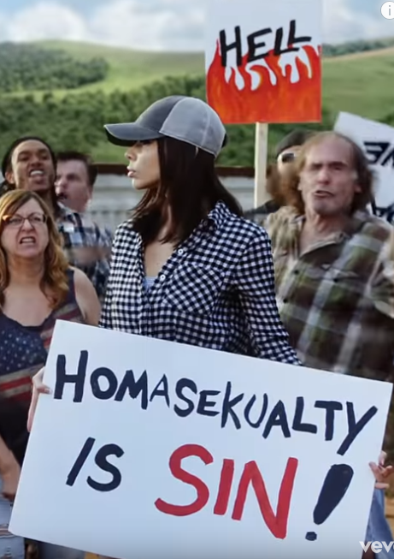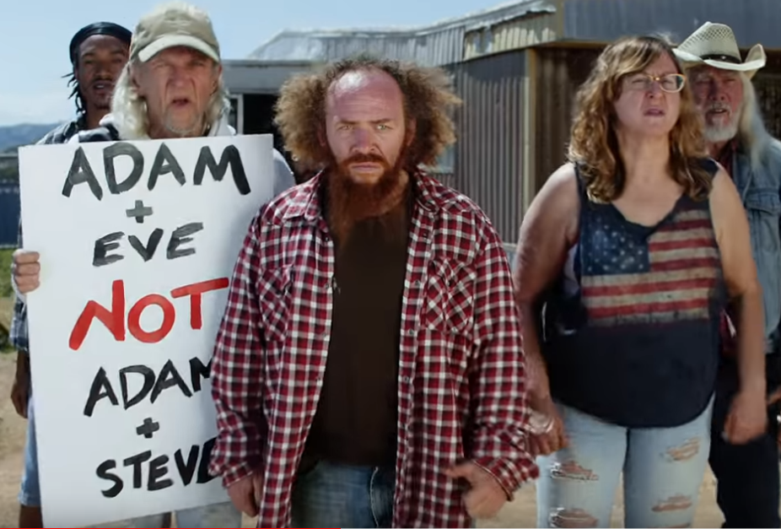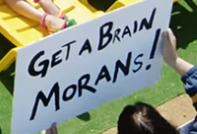


GAY ANTHEMS - document 3: “Taylor Swift releases star-studded video for "You Need To Calm Down," challenging anti-LGBTQ beliefs”
By Caitlin O'Kane, updated on: June 17, 2019 / 3:34 PM / CBS News
Taylor Swift is considered by fans to be the queen of innuendo, metaphors and hidden Easter eggs and her latest music video is chock-full of subtle nuance and not-so-subtle star power. "You Need To Calm Down" acts as an anthem for anyone who has felt a patronizing glare or has been told to "calm down" in a condescending way. And the music video celebrates the antithesis of these feelings: acceptance.
The second the synth-heavy pop tune begins, some intentional yet not-so-obvious symbols flash across the screen. First, it's a framed photo of a simple quote: "Mom, I am a rich man." Cher uttered the iconic stereotype-busting line to her mother, who suggested she settle down and marry a rich man.
Swift then throws her flaming phone on her bed — perhaps a comment on society's current addiction with technology and social media. Soon, she is laying in an above-ground pool outside of a burning mobile home.
Her trailer park is atypical — it's filled with celebrities, most of them an integral part of LGBTQ visibility. Laverne Cox waters her flowers as Dexter Mayfield dances in his yard and Hannah Hart does bicep curls with a boombox.
Later in the video, Jesse Tyler Ferguson and Justin Mikita get married – and Ciara officiates. Hayley Kiyoko, Chester Lockhart, and RuPaul also make appearances, as do cast members of "RuPaul's Drag Race." The queens are dressed like Swift and other fellow pop stars.
The real Taylor sips tea with the "Queer Eye" guys and Todrick Hall, who was an executive producer for the video.
And the famous faces keep making cameos: Ryan Reynolds focuses on a rainbow painting, Olympic skater Adam Ripon sells snow cones and Ellen DeGeneres gets a "cruel summer" tattoo from Adam Lambert. Billy Porter does his best runway walk past a group of protesters.
The protestors show up in the video often. They hold hateful — and often misspelled — signs and condemn Swift and her friends. But this group doesn't faze Swift and her pals.
The video culminates in a food fight, during which Swift, dressed like French fries, finds and comforts Katy Perry, who is dressed like a hamburger. In real life, the two singers publicly ended their infamous feud last week, with Perry sharing a photo of the cookies Swift baked her.
While this prolonged tiff has ended, Swift appears to take a jab at Kim Kardashian and Kanye West in the song. "Snakes and stones never broke my bones," she belts. When the pop star and rapper found themselves embroiled in a 2016 feud, several Instagram users "trolled" Swift by leaving a bombardment comments featuring snake emojis all over her Instagram posts.
Swift did not accept the "snake" persona at first but she took ownership of it when creating her "Reputation" album in 2017. Snakes were heavily featured in the album's songs and music videos.
Her newest album, "Lover," has a completely different vibe. "You Need To Calm Down," the second single off the yet-to-be-released LP, talks about acceptance, letting people be themselves and not putting them down — or as Swift puts it, not stepping on our gowns.
She appears to take direct aim at homophobic and anti-LGBTQ beliefs in the lyrics. "You just need to take several seats and then try to restore the peace/And control your urges to scream about all the people you hate/'Cause shade never made anybody less gay," she sings.
This is Swift's first known attempt at making a political statement in her music. […]
Source: https://www.cbsnews.com/news/taylor-swift-releases-you-need-to-calm-down-video-challenging-anti-lgbtq-beliefs-today-2019-06-17/
Activity 1: Comment on the choice of celebrities making cameo appearances.
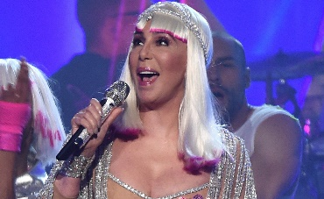  Cher (born Cherilyn Sarkisian; May 20, 1946) is an American singer, actress and television host. Commonly referred to by the media as the Goddess of Pop,^{[1]} she has been described as embodying female autonomy in a male-dominated industry. |  | 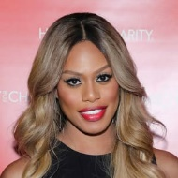  Laverne Cox  Dancer, reality TV star and actress Laverne Cox is one of the stars of 'Orange Is the New Black' and the first openly transgender person in history to receive an Emmy nomination. | 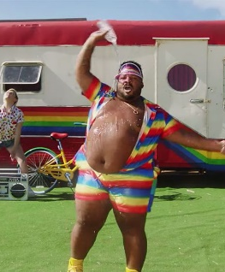  Dexter Mayfield (1984, Texas) is a famous plus size male model, known for advocating the use of plus size men on the runway. He has danced for Jennifer Lopez and Katy Perry. He has more than 10,000 followers on his Instagram account.
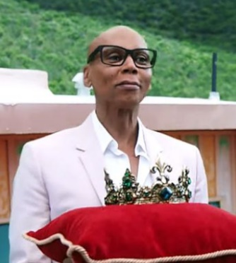  RuPaul's Drag Race is an American reality competition television series which documents RuPaul in the search for "America's next drag superstar." RuPaul plays the role of host, mentor, and head judge for this series, as contestants are given different challenges each week. | 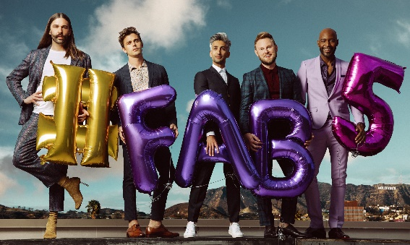  Queer Eye is an American reality television series.  Each episode features a team of gay professionals in the fields of fashion, personal grooming, interior design, entertaining and culture collectively known as the "Fab Five" performing a makeover usually for a heterosexual man: revamping wardrobe, redecorating, and offering advice on grooming, lifestyle, and food. |  |  | 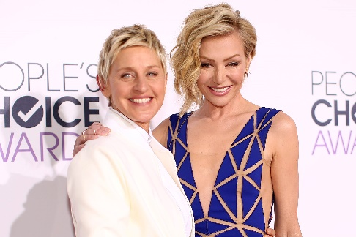  Ellen DeGeneres is an American comedian, television host, actress, writer, and producer. In 1997, DeGeneres came out as lesbian. The disclosure of her sexual orientation sparked intense interest by American tabloids.
Activity 2: Translation exercise: translate the underlined sentences on your copybook.

GAY ANTHEMS – document 4 : Being a true “Ally” or simply “pink washing”?
Taylor Swift an LGBTQI ally or not? What 'You Need To Calm Down' says about minority representation
ABC Life/ By Siobhan Hegarty Updated 7 July 2019
Is Taylor Swift an LGBTQI ally or just another celebrity cashing in on a social cause?
Earlier this month, the pop superstar released the star-studded film clip for her song You Need To Calm Down — and the reaction has been polarising, to say the least.
With its shout-out to the American LGBTQI support group GLAAD and condemnation of homophobes, the track is undeniably positioned as a gay anthem. The music video made that message even clearer by featuring well-known LGBTQI celebrities like Ru Paul, Ellen DeGeneres and the Queer Eye cast.
Some in the LGBTQI community, like Queer Eye's Karamo Brown, have applauded Swift for championing equal rights.
But others say the song conflates the criticism Swift receives as a rich, white, cis-gender celebrity with homophobic vitriol, and that it's another example of Swift strategically aligning herself with a community and movement in order to boost sales.
So, is Swift a true ally or is she hijacking the LGBTQI plight for commercial gain and cachet? And does the music video's one-dimensional portrayal of queerness actually reduce a diverse community into a sequin-loving stereotype? (…)
We're not here to hate (hate, hate, hate) on Swift or praise her for finally getting political. We're simply using the uncomfortable questions her latest song poses as a way to consider the real ethical issue: representation and misrepresentation in pop culture.
Last month, Swift started a Change.Org petition for the US Senate to support the Equality Act, designed to protect LGBTQI people from discrimination in their places of work, homes, schools and public accommodation. Indeed, her latest film clip pushes to the petition. (…)
So, why the fuss about her new song?
Joshua Badge is a lecturer in philosophy at Deakin University and a queer activist. He says Swift's sudden support should be examined closely.
"If the criticism of her work previously is that she's been too apolitical, releasing a gay pride song during Gay Pride Month attached to a political petition to change laws — well, that's just an excellent business move, isn't it?" he says.
For Mr Badge, the timing, aesthetic and political nature of her new song could be viewed as what's known in queer theory as pink washing.
"Pink washing is a kind of marketing strategy of promoting brands or products by depicting them as gay-friendly or gay-inclusive," he explains.
"Performing this gay-friendliness or 'allyship', as you might call it, is a way for an individual to gain social or political capital because gay rights are this kind of marker of civilisation and modernity.
"But to think about it critically for a second, it is effectively a way of profiting off human rights struggles."
Through visually and lyrically showing her support for LGBTQI rights and featuring a bunch of queer celebrities in her clip, Swift stands to gain millions of dollars.
But some don't think that's such a bad thing.
Salvatore Babones, an American-born sociologist and associate professor at the University of Sydney, says "cashing in on current trends" is what pop artists do.
"Would we want there to be a sombre Gay Pride Month every June where everybody who is not gay stayed silent, stayed home, did nothing to mention queerness or gay rights because that must belong to gay people and was their specialty?" he posits.
"I think that would be a terrible solution, but that's the solution implied by saying that a straight artist can't do a bad job of celebrating queerness.
"Of course, Taylor Swift can make a video that she believes is supporting the queer community, and she can do it during Gay Pride Month and she can do it to try and make money. (…)
Double J's Caz Tran explains, "[In the song] she is talking about herself and sort of equating the hardship she has encountered as a high-profile celebrity with the longstanding suffering, persecution and denigration and every word to describe the adversity the queer community has faced. That makes me uncomfortable as a listener.” (…)
According to Mr Badge, the LGBTQI stars appear almost like "props" in Swift's narrative. Instead of choosing to collaborate with an artist from the queer community — and split the profits of the song with them — she's at the centre of the narrative.
And herein lies the problem with someone sharing the story of a community of which he or she isn't a part.
"The danger of having stories told by people who don't have the authority of experience is that they're really one-dimensional," says Mr Badge.
Activity 1: Choose 2 colours and highlight
________ The elements allowing you to think that Taylor Swift is an LGBTQI+ Ally
________ The elements casting doubt on her sincerity.
Activity 2: Rephrase them in your own words.
Extra articles: you can read the whole article here: (our document represents about a third of the whole article) https://www.abc.net.au/life/taylor-swift-lgbtiq-ally-or-hijacker-with-you-need-to-calm-down/11261124
Also, read what Maeve McDermott, USA Today Network journalist, says about it.
https://chicago.suntimes.com/2019/6/21/18701157/taylor-swift-you-need-to-calm-down-controversy-explained

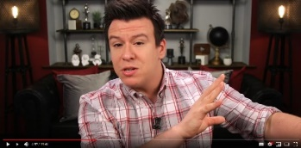
Extra video: Watch what Philip DeFranco, news commentator and American YouTube personality has to say about this (from 2min27 to 4min55).
https://www.youtube.com/watch?v=P07x61lheg8

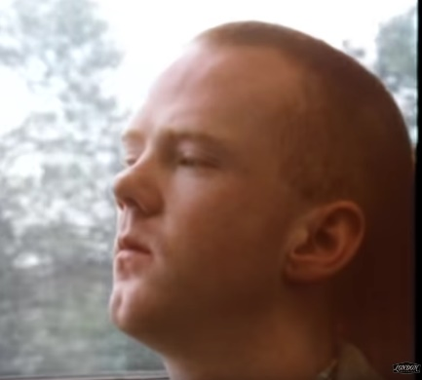
GAY ANTHEMS - Document 5 : A few famous gay anthems
Below are three gay anthems, two of them with illustrating music videos.
Objective of the task: List some themes that seem to underlie (sous-tendre) gay anthems.

“Smalltown Boy”, Bronski Beat, 1984
Video: https://www.youtube.com/watch?v=88sARuFu-tc

You leave in the morning
With everything you own
In a little black case
Alone on a platform
The wind and the rain
On a sad and lonely face
Mother will never understand
Why you had to leave
But the answers you seek
Will never be found at home
The love that you need
Will never be found at home
Run away, turn away, run away, turn away, run away
Run away, turn away, run away, turn away, run away
Pushed around and kicked around
Always a lonely boy
You were the one
That they'd talk about around town
As they put you down
And as hard as they would try
They'd hurt to make you cry
But you never cried to them
Just to your soul
No, you never cried to them
Just to your soul
Run away, turn away, run away, turn away, run away
Run away, turn away, run away, turn away, run away
Cry, boy, cry...

“Born This Way”, Lady Gaga, 2011
[Intro]
It doesn't matter if you love him, or capital "H-I-M" (M, M, M)
Just put your paws up
'Cause you were born this way, baby
[Verse 1]
My mama told me when I was young
We are all born superstars
She rolled my hair and put my lipstick on
In the glass of her boudoir
"There's nothing wrong with loving who you are"
She said, "'Cause he made you perfect, babe"
"So hold your head up, girl, and you'll go far
Listen to me when I say"
[Chorus]
I'm beautiful in my way
'Cause God makes no mistakes
I'm on the right track, baby
I was born this way
Don't hide yourself in regret
Just love yourself, and you're set
I'm on the right track, baby
I was born this way (Born this way)
[Post-Chorus]
Ooh, there ain't no other way
Baby, I was born this way
Baby, I was born this way (Born this way)
Ooh, there ain't no other way
Baby, I was born this way
Right track, baby
I was born this way
[Interlude]
Don't be a drag, just be a queen (x3)
Don't be (Don't be, don't be)
[Verse 2]
Give yourself prudence and love your friends
Subway kid, rejoice your truth
In the religion of the insecure
I must be myself, respect my youth
A different lover is not a sin
Believe capital H-I-M
Hey, hey, hey
I love my life, I love this record and
Mi amore vole fe yah (Same DNA)
[Chorus]
I'm beautiful in my way
'Cause God makes no mistakes
I'm on the right track, baby
I was born this way
Don't hide yourself in regret
Just love yourself, and you're set
I'm on the right track, baby
I was born this way (Born this way)
[Post-Chorus]
Ooh, there ain't no other way
Baby, I was born this way
Baby, I was born this way (Born this way)
Ooh, there ain't no other way
Baby, I was born this way
Right track, baby
I was born this way
[Interlude]
(Way) Don't be, don't be...
(Way) Church
[Breakdown]
Don't be a drag, just be a queen
Whether you're broke or evergreen
You're black, white, beige, cholo descent
You're Lebanese, you're orient
Whether life's disabilities
Left you outcast, bullied, or teased
Rejoice and love yourself today
'Cause baby, you were born this way
[Bridge]
No matter gay, straight, or bi
Lesbian, transgender life
I'm on the right track, baby
I was born to survive
No matter black, white, or beige
Chola or orient made
I'm on the right track, baby
I was born to be brave!

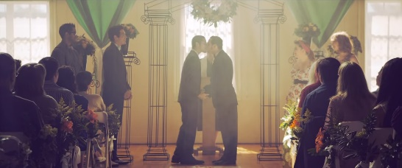
“Same Love”, Macklemore & Ryan Lewis feat. Mary Lambert, 2012
Video : https://www.youtube.com/results?search_query=same+love
When I was in the third grade I thought that I was gay
'Cause I could draw, my uncle was, and I kept my room straight
I told my mom, tears rushing down my face
She's like "Ben you've loved girls since before Pre-K, trippin'"
Yeah, I guess she had a point, didn't she?
Bunch of stereotypes all in my head
I remember doing the math like, "Yeah, I'm good at Little League"
A pre-conceived idea of what it all meant
For those that like the same sex
Had the characteristics
The right-wing conservatives think it's a decision
And you can be cured with some treatment and religion
Man-made rewiring of a pre-disposition
Playing God, aw nah here we go
America the brave still fears what we don't know
And "God loves all his children" is somehow forgotten
But we paraphrase a book written thirty-five hundred years ago
I don't know
[Mary Lambert:]
And I can't change
Even if I tried
Even if I wanted to
And I can't change
Even if I tried
Even if I wanted to
My love (x3)
She keeps me warm (x4)
[Macklemore:]
If I was gay, I would think hip-hop hates me
Have you read the YouTube comments lately?
"Man, that's gay" gets dropped on the daily
We've become so numb to what we're sayin'
Our culture founded from oppression
Yet we don't have acceptance for 'em
Call each other faggots behind the keys of a message board
A word rooted in hate, yet our genre still ignores it
"Gay" is synonymous with the lesser
It's the same hate that's caused wars from religion
Gender to skin color, the complexion of your pigment
The same fight that led people to walk-outs and sit-ins
It's human rights for everybody, there is no difference
Live on and be yourself
When I was at church they taught me something else
If you preach hate at the service those words aren't anointed
That holy water that you soak in has been poisoned
When everyone else is more comfortable remaining voiceless
Rather than fighting for humans that have had their rights stolen
I might not be the same, but that's not important
No freedom 'til we're equal, damn right I support it
(I don't know)
[Mary Lambert:] idem
[Macklemore:]
We press play, don't press pause
Progress, march on
With a veil over our eyes
We turn our back on the cause
'Til the day that my uncles can be united by law
When kids are walking 'round the hallway plagued by pain in their heart
A world so hateful some would rather die than be who they are
And a certificate on paper isn't gonna solve it all
But it's a damn good place to start
No law is gonna change us
We have to change us
Whatever God you believe in
We come from the same one
Strip away the fear
Underneath it's all the same love
About time that we raised up
[Mary Lambert:] idem +
Love is patient
Love is kind
(Not crying on Sundays) (x4)
Love is patient

https://genius.com/916457 On Genius, the lyrics of some songs are explained. Go and check the explanations for « Same Love » ; they will help you understand this anthem.

Activity 1:
Read the lyrics of the 3 songs and watch the 2 videos.
Activity 2:
Focus on one of the 3 songs. Ponder over (réfléchir à) the lyrics -especially the expressions in bold- and on the situations presented in the videos. Jot your reflections down on paper.
Activity 3:
Present your findings/ reflections to classmates who have not worked on “your” song. Listen to their findings/ reflections about the other 2 songs.
Activity 4:
List some themes that seem to underlie (sous-tendre) gay anthems.
Tip: representing your idea with a mindmap centering on “gay anthems” can be handy

GAY ANTHEMS– document 6 : The Equality Act and Education
Useful elements for a running dictation
coma , period . colon: semi-colon ; Quote « Unquote »
Hyphen - Question mark ?
Start a new line (à la ligne)
March 2021
The Equality Act, which would prohibit discrimination on the basis of sex, sexual orientation and gender identity, is moving to the Senate after being passed by the House of Representatives – and it could affect what's taught in classrooms.
The Equality Act would enable protections within education, particularly on how teachers implement LGBTQ-inclusive curriculum.
"It signals to educators who are not part of our community that they, too, can hopefully implement language, representation and curriculum that is LGBTQ inclusive," the director of Education and Youth Programs at the LGBTQ+ education advocacy group GLSEN said.
Up until the late 2000s, most LGBTQ+-inclusive teaching was pushed aside or hidden from students – if it wasn’t actively discouraged by states. Five states – Alabama, Louisiana, Mississippi, Oklahoma and Texas – have laws that forbid teachers from discussing LGBTQ+ topics in a positive light. In contrast, five states – California, Colorado, Illinois, New Jersey and Oregon, as well as some counties in Maryland and Virginia – have laws that force teachers to be inclusive of the LGBTQ community. Some laws demand that teachers portray LGBTQ topics in a negative light.
Even in states where restrictive laws don’t exist, some teachers don’t feel comfortable teaching these topics because of lack of support within their school districts, from their principal or from the parents. There could be actual repercussions for them.
The Equality Act could change that. It would protect LGBTQ teachers and could empower other educators to teach inclusively without fear of being fired.
Research shows having LGBTQ storylines in the classroom affects all students positively, not just those who think they may be LGBTQ.
Comprehension questions – right or wrong? Highlight the element that contains the justification in the text.
1.A bill (=a law project) must go to the House of Representatives before going to the Senate. R W
2.The Equality Act will defend teachers who use LGBTQ-inclusive language. R W
3.Mississippi has always been pro-inclusion. R W
4.In California, teachers can either be inclusive or not; it’s their own choice. R W
5.In the US, it is easy and safe for teachers to teach inclusively. R W
6.Including LGBTQ examples/content in lessons has a positive impact on LGBTQ students only. R W
https://eu.usatoday.com/story/news/education/2021/03/06/lgbtq-history-equality-education-act-teachers/6648601002/
GAY ANTHEMS Document 6 – “How the LGBTQ community is still fighting for rights years after Stonewall”, video by USA Today
https://eu.usatoday.com/story/news/education/2021/03/06/lgbtq-history-equality-education-act-teachers/6648601002/
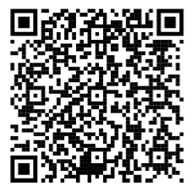
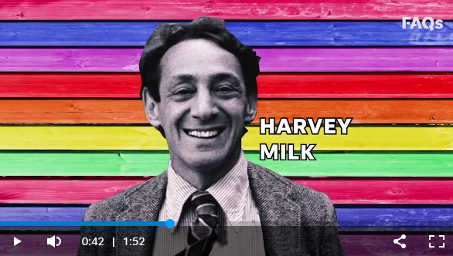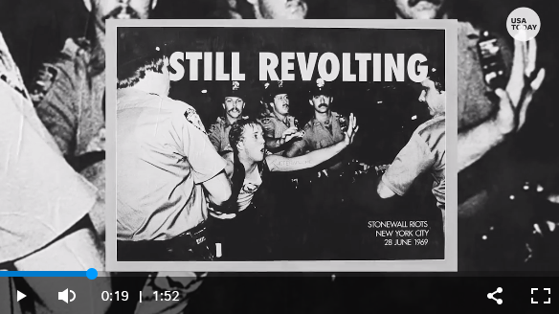
“Still fighting”
Gay rights have come a long way in the US but the LGBTQ community still faces threats in the form of legislation, discrimination and even violence.
In 1969, New York City Police raided Stonewall Inn, a gay bar in Greenwich Village. Riots broke out sparkling 6 days of violent protest known as the Stonewall Riots. Days after the Stonewall uprising, LGBTQ rights demonstrations took place in New-York. This is generally considered the first major demonstration for gay rights.
One year later, in 1970 came the first Pride marches. 8 years after that, the iconic 6-stripe rainbow flag was created at the request of activist Harvey Milk and became the stamp of pride.
In 2015 came another milestone. The Supreme Court legalized same-sex marriage nationwide but this didn’t mean the end of discrimination.
LGBTQ Americans still face legalized discrimination when it comes to housing, jobs, healthcare, parenting, and even prison. Many states still lack laws banning discrimination based on sexual orientation and bills that would curtail gay rights keep appearing. In 2018, more than 100 bills were proposed that the human rights campaigns consider anti- LGBTQ. Examples include Religious Freedom Acts, religious exemptions and transgender bathrooms laws. In 2020, at least 44 transgender people were killed, most of whom were transgender women and people of colour. These fatalities were reported in 18 states and Puerto Rico and across 32 cities and towns. And in 2021 state legislators across the country saw more than 2 050 more anti-LGBTQ laws many of which targeted transgender youth.
LVA
LVB


Document 4 : « Canned in Kenya, set for Cannes : Rafiki falls foul of Nairobi film censors », The Guardian, April 27, 2018
It is a coming-of-age tale of two girls, the daughters of political opponents, who fall in love and find their identity and dreams compromised by a conservative society.
Bringing their story to the screen has proved a triumph for director Wanuri Kahiu, who made history last week after it was announced that Rafiki would be the first Kenyan film to feature at the Cannes film festival, which begins in May.
Yet the fiction is all too close to reality after it was announced on Friday that Kenyan authorities have banned the film due to its “clear intent to promote lesbianism”.
According to the Kenya Film Classification Board (KFCB), the movie Rafiki – which means “friend” in KiSwahili – contravenes national laws and culture.
Ezekiel Mutua, the board’s chief executive, announced: “The Kenya Film Classification Board has banned the film Rafiki due to its homosexual theme and clear intent to promote lesbianism in Kenya contrary to the law and dominant values of the Kenyans.”
Oddly, the ban comes just days after Mutua applauded the award-winning director Kahiu, who won a clutch of accolades for her 2008 film, From a Whisper.
Speaking in a live radio interview he said: “I had a great meeting with Wanuri Kahiu, one of the greatest Kenyans that we have in the film industry and her movie has been nominated. Cannes is big. Other than the Oscars, Cannes is the best.”
Yet a press statement issued on Friday warned that anyone who distributed, exhibited or broadcast the film in Kenya, or was found to be in possession of the film, would be in breach of the law.
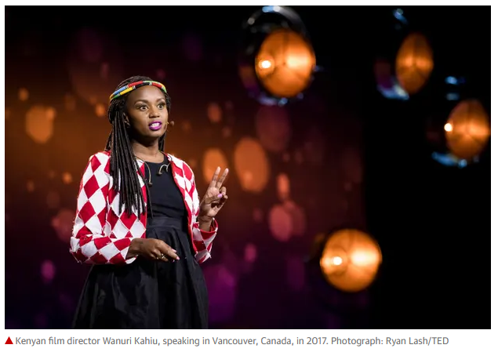
Kahiu took to Twitter to express her dismay, writing: “I am incredibly sorry to announce that our film Rafiki has been banned in Kenya. We believe adult Kenyans are mature and discerning enough to watch local content but their right has been denied.”
Homosexuality is illegal in Kenya and gay sex is punishable by 14 years in prison. […]
The KFCB claims romantic scenes depicting the lead actors as lesbians were absent in the original script and that it would pursue legal avenues to holding the producers to account.
“In the script the lead actors were portrayed as having been attacked for political reasons, having formed a political party feigning unity between their parents whereas in the film they were obviously attacked for being homosexual,” it said in a statement.
It also signalled a warning to foreign agencies involved in the promotion of the film, urging them to respect Kenyan culture and “desist from funding content that undermines the sensibilities of the Kenyan people”.
It said: “Hare-brained schemes by foreigners funding film producers in Kenya to promote homosexuality in the name of equality and inclusion will be exposed and strongly resisted.”
Board spokeswoman Nelly Muluka tweeted: “Our culture and laws recognise family as the basic unit of society. The [board] cannot, therefore, allow lesbian content to be accessed by children in Kenya.”
Kahiu said: “I’m really disappointed because Kenyans already have access to watch films that have LGBT content, on Netflix, and in international films shown in Kenya and permitted by the classification board itself. So to then just ban a Kenyan film because it deals with something already happening in society just seems like a contradiction.”
Homosexuality is taboo across the majority of African nations and people who are gay face discrimination or persecution. In recent years, however, campaigners for lesbian, bisexual, gay and transgender rights have become increasingly vocal. (…)
Source : https://www.theguardian.com/global-development/2018/apr/27/kenya-rafiki-film-nairobi-censors-cannes-wanuri-kahiu
Activity 1: Choose 4 colours and highlight
________ The recognition that Rafiki and her director received.
________ The reasons why the Kenya Film Classification Board has decided to ban Rafiki.
________ The measures the Kenya Film Classification Board implement to have this ban respected.
________ Kahiu’s reactions.
Activity 2: Rephrase in your own words.


Extra reading on the topic : « Banning African films like Rafiki and Inxeba doesn’t diminish their influence », The Conversation, June 17, 2021
Source : https://theconversation.com/banning-african-films-like-rafiki-and-inxeba-doesnt-diminish-their-influence-162315

Document 4 : « Canned in Kenya, set for Cannes : Rafiki falls foul of Nairobi film censors », The Guardian, April 27, 2018
It is a coming-of-age tale of two girls, the daughters of political opponents, who fall in love and find their identity and dreams compromised by a conservative society.
Bringing their story to the screen has proved a triumph for director Wanuri Kahiu, who made history last week after it was announced that Rafiki would be the first Kenyan film to feature at the Cannes film festival, which begins in May.
Yet the fiction is all too close to reality after it was announced on Friday that Kenyan authorities have banned the film due to its “clear intent to promote lesbianism”.
According to the Kenya Film Classification Board (KFCB), the movie Rafiki – which means “friend” in KiSwahili – contravenes national laws and culture.
Ezekiel Mutua, the board’s chief executive, announced: “The Kenya Film Classification Board has banned the film Rafiki due to its homosexual theme and clear intent to promote lesbianism in Kenya contrary to the law and dominant values of the Kenyans.”
Oddly, the ban comes just days after Mutua applauded the award-winning director Kahiu, who won a clutch of accolades for her 2008 film, From a Whisper.
Speaking in a live radio interview he said: “I had a great meeting with Wanuri Kahiu, one of the greatest Kenyans that we have in the film industry and her movie has been nominated. Cannes is big. Other than the Oscars, Cannes is the best.”
Yet a press statement issued on Friday warned that anyone who distributed, exhibited or broadcast the film in Kenya, or was found to be in possession of the film, would be in breach of the law.
Kahiu took to Twitter to express her dismay, writing: “I am incredibly sorry to announce that our film Rafiki has been banned in Kenya. We believe adult Kenyans are mature and discerning enough to watch local content but their right has been denied.”
Homosexuality is illegal in Kenya and gay sex is punishable by 14 years in prison. […]
The KFCB claims romantic scenes depicting the lead actors as lesbians were absent in the original script and that it would pursue legal avenues to holding the producers to account.
“In the script the lead actors were portrayed as having been attacked for political reasons, having formed a political party feigning unity between their parents whereas in the film they were obviously attacked for being homosexual,” it said in a statement.
It also signalled a warning to foreign agencies involved in the promotion of the film, urging them to respect Kenyan culture and “desist from funding content that undermines the sensibilities of the Kenyan people”.
It said: “Hare-brained schemes by foreigners funding film producers in Kenya to promote homosexuality in the name of equality and inclusion will be exposed and strongly resisted.”
Board spokeswoman Nelly Muluka tweeted: “Our culture and laws recognise family as the basic unit of society. The [board] cannot, therefore, allow lesbian content to be accessed by children in Kenya.”
Kahiu said: “I’m really disappointed because Kenyans already have access to watch films that have LGBT content, on Netflix, and in international films shown in Kenya and permitted by the classification board itself. So to then just ban a Kenyan film because it deals with something already happening in society just seems like a contradiction.”
Homosexuality is taboo across the majority of African nations and people who are gay face discrimination or persecution. In recent years, however, campaigners for lesbian, bisexual, gay and transgender rights have become increasingly vocal. (…)
Source : https://www.theguardian.com/global-development/2018/apr/27/kenya-rafiki-film-nairobi-censors-cannes-wanuri-kahiu
Activity 1: Choose 4 colours and highlight
________ The recognition that Rafiki and her director received.
________ The reasons why the Kenya Film Classification Board has decided to ban Rafiki.
________ The measures the Kenya Film Classification Board implement to have this ban respected.
________ Kahiu’s reactions.
Activity 2: Rephrase in your own words.

Extra reading on the topic : « Banning African films like Rafiki and Inxeba doesn’t diminish their influence », The Conversation, June 17, 2021
Source : https://theconversation.com/banning-african-films-like-rafiki-and-inxeba-doesnt-diminish-their-influence-162315

GAY ANTHEMS Speaking test/ personal synthesis of part 1
NAME : ………………………………………………………….
Do you think that “You Need to Calm Down” in particular but also gay anthems/ songs can help change mentalities and promote LGBTQI+ inclusion? What actual impact do you think this sort of song can make?
Use the content of the chapter to express your personal point of view. Make sure you justify it.
Speak for a minimum of 3 minutes and a maximum of 5 minutes. Be organized in your answer.
Points qui nécessitent d’être retravaillés :
Contenu | Vocabulaire | Syntaxe | Formes verbales | Prononciation
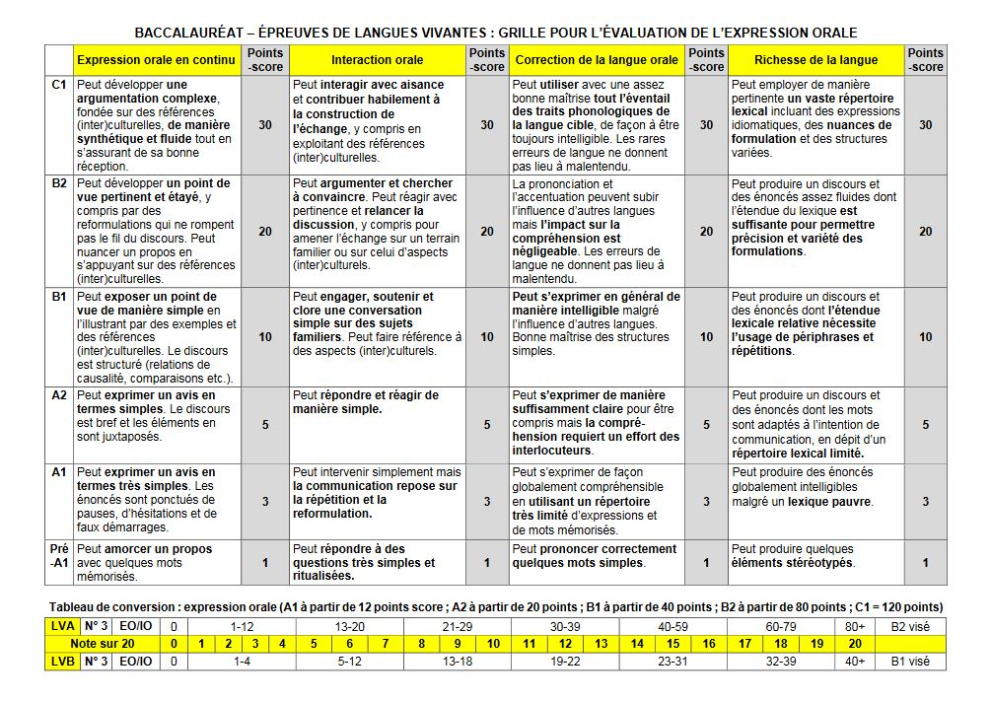

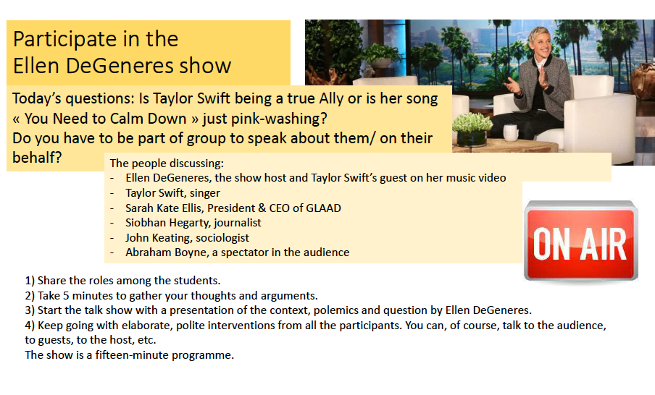


TRAAM-TLSE-ANG002 / Gay Marriage

I. Introduction

- Nature du document : Video transformable en audio
- Langue : anglais
- Durée : 1’30
- niveau Lycée B1-B2
- bref résumé du contenu :
Une jeune fille et un jeune homme britanniques opposent leur point de vue sur la légalisation du mariage gay.

- Lien avec les notions des programmes :
Espace & Echange, l’Idée de Progrès, Lieux et Formes du Pouvoir

II. Références
Disponible sur :
http://pedagogie2.ac-reunion.fr/cyberprofLV/telechargements/podcaz_Bac_anglais/IP-Gay_marriage.avi

- Script audio : B=Boy / G= Girl

B: So, have you heard the...uh... issue at the moment about gay marriage?
G: Yes.
B: Like people want to legalise it and things like this.
G: Yeah I think that it definitely should be legalised, I think that gay people have the same rights as everyone else and they should be allowed to get married.
B: No but…hum... marriage is a religious institution, and it shouldn’t be…uh... you can’t bend the rules of this institution for gay people, it’s just not right.
G: But…but why not becau(se) the church...Religions have had to adapt to lots of things recently in history and they should have to adapt to the fact that homosexuality is now completely accepted and socially normal.
B: Yeah but not in terms of marriage, I still don’t think you can, I don’t think it’s fair. Like you…uh... gay people, they can’t raise a child in the same way, there’s an imbalance, like you don’t have the male or the female like...uh...balance that you normally should and things like this.
G: But there are so many children whose parents put them up for adoption or they have to live in foster homes, surely it’s better that they have two parents who love them and care for them even if they’re the same sex too…uh… and a lot of people grow up in single parent households which is no better for them than growing up in a household with two parents of the same sex. Why should they have less right than everyone else?
B: I just think, you know, it’s…uh… it makes a mockery of the entire institution, I...I agree that...uh… gay people should have civil partnerships or things like this but to have actual marriage is just, no, absolutely not, I completely disagree.
G: I think that in this day and age everyone ought to be equal and that includes people of all different sexualities and…so I think gay marriage should be legalised.

- Tableau avec éléments de contenu à repérer, classés par niveau de compréhension du CECRL

HORS CADRE | Compréhension insuffisante  Le candidat n'a pas compris le document. Il n'en a repéré que des éléments isolés et n’est pas parvenu à en identifier le thème ni qui parle.
Eléments relevant du niveau  A1 | Compréhension superficielle  Le candidat est parvenu à relever des mots isolés, des expressions courantes et à les mettre en relation pour construire une amorce de compréhension du document. Le candidat a compris seulement les phrases/les idées les plus simples et n’a pas pleinement identifié qui est pour et/ou qui est contre.  Repérage des idées les plus simples :  → une jeune fille et un jeune homme discutent du mariage gay  → ils n’ont pas l’air d’accord
Eléments relevant du niveau  A2 | Compréhension partielle  Certaines informations ont été comprises mais le relevé est incomplet conduisant à une compréhension encore lacunaire ou partielle. Le candidat a su identifier le thème et repérer le rôle des interlocuteurs.  Repérage des locuteurs et de leur rôle:  → une jeune femme et un jeune homme (britanniques > accent) échangent leur point de vue sur le mariage gay  → le jeune homme qui initie la conversation est contre alors que la jeune-fille est pour  Repérage du thème :  → il y a actuellement un débat autour du mariage gay et de sa légalisation car :  - le premier problème posé est que le mariage est une institution religieuse  - le deuxième problème posé est l’éducation des enfants (par un couple du même sexe)  Repérage d’éléments isolés / de mots :  → issue / gay marriage / legalise  → (same) rights / equal  → religious (institution) / history  → homosexuality / male / female / balance / fair  → children / adoption
Eléments relevant du niveau  B1 | Compréhension satisfaisante  Le candidat a su relever les points principaux de la discussion (contexte, objet, personnes concernées , conclusion de l’échange)  Repérage des idées principales :  → la jeune femme pense que le mariage gay devrait être légalisé car ils ont les mêmes droits que les autres, donc on devrait les autoriser à se marier  → le jeune homme est opposé au mariage gay car c’est une institution religieuse dont on ne peut changer les règles, ce ne serait pas « juste »  → la jeune femme pense que c’est à l’Eglise de s’adapter et de comprendre que l’homosexualité est quelque chose de normal  → le jeune homme rétorque que ce n’est pas « juste », car ils ne peuvent éduquer un enfant de la même façon qu’un couple hétérosexuel : il n’y aurait pas les deux principes masculin et féminin.  → La jeune femme pense qu’il vaut mieux avoir deux parents du même sexe qui aiment et s’occupent de leurs enfants plutôt que de grandir dans une famille monoparentale  → le jeune homme est d’accord pour que les homosexuels puissent avoir des droits de partenaires par les institutions civiles mais il est farouchement opposé au mariage pour les gays  → elle conclut enfin que le mariage entre deux personnes du même sexe devrait être autorisé pour respecter l’égalité des droits entre les êtres humains, y compris en terme de sexualité
Eléments relevant du niveau  B2 | Compréhension fine  Le candidat a saisi et relevé un nombre suffisant de détails significatifs et leur logique interne. Le contenu informatif a été compris ainsi que l’attitude du locuteur (ton, humour, points de vue, etc.).  Repérage des éléments de compréhension plus fine / de l’implicite / du point du vue :  → L’argument principal du jeune homme est celui de ‘l’institution sacrée du mariage’ qui doit unir un homme et une femme pour qu’ils puissent fonder une famille et éduquer des enfants. C’est un principe religieux dont on ne peut modifier les règles pour les gays, au risque de mettre en péril toute l’institution.  → Pour la jeune femme, il s’agit plus d’une question de respect des droits fondamentaux de l’être humain : de nos jours tous les êtres humains devraient être égaux, y compris les gens qui n’ont pas les mêmes aspirations sexuelles.  Dans l’histoire récente l’Eglise a dû s’adapter à de nombreuses choses, c’est pourquoi elle s’étonne qu’elle ne puisse s’adapter au fait que l’homosexualité est à présent complètement acceptée et normale socialement parlant.  Quant au problème de l’éducation des enfants, pour elle c’est un faux problème : tant d’enfants se retrouvent à l’orphelinat ou dans des familles d’accueil ! L’amour est plus important que les principes.

To belt (music) = to play loudly
Smalltown = provincial
To fall foul of = to get into trouble / to contravene sthg
To fall foul of = to get into trouble / to contravene sthg

